Cairo University

Faculty of Computers and Information

Computer Science

2015

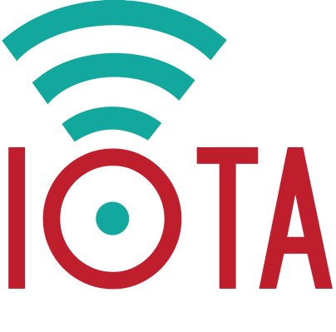

**IOTA**

Internet of Things Development Platform

**Supervised By**

Dr Akram Salah

**Prepared By**

Hady ElHady

Ahmed AbdElHammed

Waleed Ziad

Mohamed Ahmed

Ashraf Mohey

20110398

20110083

20110417

20110283

20110114

# Table of Contents

Table of Contents ii

List of Figures v

Preface vii

Summary vii

Introduction vii

Acknowledgements vii

**Chapter 1** 1

1. Introduction 2

1.1. Concept 2

1.2. Problem Definition 2

1.3. Suggested Solution 2

1.4. Objective 2

1.5. Plan 3

**Chapter 2** 4

2. Feasibility Study and Analysis 5

2.1. Feasibility Study 5

2.1.1. Quora 5

2.1.2. Study 9

2.2. Analysis 10

2.2.1. Hardware: Raspberry Pi 10

2.2.2. Technologies Used 11

2.2.3. Existing Products 14

**Chapter 3** 16

3. Requirements and Design 17

3.1. Introduction 17

3.1.1. Product Overview 17

3.2. Specific Requirements 17

3.2.1. External Interface Requirements 17

3.2.2. Software Product Features 18

3.2.3. Software System Attributes 20

3.2.4. Database Requirements 21

3.3. Architectural Design 22

3.3.1. Introduction 22

3.3.2. Architectural Representation 22

3.3.3. Architectural Goals and Constraints 22

3.3.4. Use-Case View 23

3.3.5. Logical View 24

3.3.6. Process View 25

3.3.7. Module Decomposition View 26

3.3.8. Database Design 27

3.4. Conceptual Design 27

3.4.1. Experiential Flowchart 27

3.4.2. Implementation Plan 28

**Chapter 4** 29

4. Implementation 30

4.1. Home Page 30

4.1.1. Home 30

4.1.2. About 31

4.1.3. Login 31

4.1.4. Sign Up 33

4.1.5. Contact Us 34

4.2. Dashboard 34

4.2.1. Add Device 36

4.2.2. Add Feed 36

4.2.3. Device Page 37

4.2.4. Device IDE 38

4.2.5. Server IDE 39

4.3. Mobile Compatibility 39

4.3.1. Mobiles 40

4.3.2. Tablets 42

**Chapter 5** 44

5. Testing and Conclusions 45

5.1. Testing 45

5.1.1. Home Navigation Test Cases 45

5.1.2. Sign Up Test Cases 45

5.1.3. Login Test Cases 50

5.1.4. Dashboard Functionalities Test Cases 51

5.1.5. Device Page Functionalities Test Cases 57

5.1.6. IDE Test Cases 58

5.2. Conclusions 63

5.2.1. Future Work 63

**Appendix I** 65

I. Glossary 66

References 70

# List of Figures

Figure ‎2.1. Question Asked on Quora 5

Figure ‎2.2. Answer by Jim Reich on Quora 6

Figure ‎2.3. Answer by Zhou Mingchun on Quora 7

Figure ‎2.4. Answer by Rushik Upadhyay on Quora 8

Figure ‎2.5. Mobile Connected Devices Study 9

Figure ‎2.6. Raspberry Pi 10

Figure ‎2.7. Xively Logo 14

Figure ‎2.8. Particle Logo 15

Figure ‎3.1. Use Case View 23

Figure ‎3.2. IOTA Logical View 24

Figure ‎3.3. IOTA Process View 25

Figure ‎3.4. IOTA Module Decomposition View 26

Figure ‎3.5. IOTA Data View 27

Figure ‎3.6. Implementation Plan Timeline 28

Figure ‎4.1. Home Page 30

Figure ‎4.2. Home Page – About 31

Figure ‎4.3. Home Page – Login and Sign Up 31

Figure ‎4.4. Login Page 32

Figure ‎4.5. Forgot Password Page 32

Figure ‎4.6. Sign Up Page 33

Figure ‎4.7. Home Page - Contact Us 34

Figure ‎4.8. IOTA Dashboard 35

Figure ‎4.9. IOTA Dashboard - Received Feeds 35

Figure ‎4.10. IOTA Dashboard Themes 36

Figure ‎4.11. Add Device Page 36

Figure ‎4.12. Add Feed Page 37

Figure ‎4.13. Device Page 37

Figure ‎4.14. Device Data 38

Figure ‎4.15. Device IDE Page 38

Figure ‎4.16. Server IDE Page 39

Figure ‎5.1. Home Page Navigation 45

Figure ‎5.2. Home Page Login Section 45

Figure ‎5.3. Home Page Sign Up Section 45

Figure ‎5.4. Blank First Name Error 46

Figure ‎5.5. Blank Last Name Error 46

Figure ‎5.6. Blank Email Address Error 47

Figure ‎5.7. Invalid Email Address Error 47

Figure ‎5.8. Blank Password/Confirm Password Error 48

Figure ‎5.9. Password and Confirm Password Don't Match Error 48

Figure ‎5.10. Password Missing Lowercase Letter Error 49

Figure ‎5.11. Password Missing Uppercase Letter Error 49

Figure ‎5.12. Filled Registration Form 50

Figure ‎5.13. User Database Entry 50

Figure ‎5.14. Filled Login Form 51

Figure ‎5.15. IOTA Dashboard 51

Figure ‎5.16. Add Device Page 52

Figure ‎5.17. Blank Device Name Error 52

Figure ‎5.18. Filled Device Name 53

Figure ‎5.19. Device Button on Dashboard 53

Figure ‎5.20. Device Database Entry 53

Figure ‎5.21. Add Feed Page 54

Figure ‎5.22. Add Feed Devices' Dropdown List 54

Figure ‎5.23. Blank Feed Name Error 55

Figure ‎5.24. Filled Add Feed Form 55

Figure ‎5.25. Feed Database Entry 56

Figure ‎5.26. Devices' Buttons on Dashboard 56

Figure ‎5.27. Device Page 57

Figure ‎5.28. Sign Out 57

Figure ‎5.29. Device IDE 58

Figure ‎5.30. Server IDE 58

Figure ‎5.31. C++ Successful Run 59

Figure ‎5.32. Namespace Undeclared 59

Figure ‎5.33. Java Successful Run 60

Figure ‎5.34. GET_DATA Function 61

Figure ‎5.35. Main Class Error 61

Figure ‎5.36. Incorrect Java Code 62

# Preface

## Summary

The Internet of Things (IOT) is one of the booming concepts in technologies nowadays. However due to many reasons that will be discussed later on, there’s a lack of IOT applications mainly due the infeasibility of developing ones with ease.

In this document we talk about our project IOTA (Internet of Things Application), which is an Internet of Things Development Platform that allows the user to develop IOT applications and track them on different devices with ease and simplicity.

## Introduction

The purpose of this document is introduce the readers to our project and take them through the different phases that we went through to complete it, from the early inception stage until the final implementation and testing phases.

The audience wants to know more about our project, the stages that went into its implementation and the final results achieved through it. They don’t necessarily need to have a previous background about the topic. Jargon and terminology will be used as most of the terminology concerning the topic is already known but most of it will also be available in a glossary at the end as per need.

## Acknowledgements

First and foremost, we would like to thank our mentor, Dr Akram Salah for his valuable advice and mentoring. Without his guidance we wouldn’t have been able to accomplish this project.

We would also like to thank each and every single professor and teaching assistant that has played a role in shaping our minds and providing us with the knowledge gained throughout our four years in university that was used throughout the many different phases of this project.

# **Chapter 1**

**Introduction**

*"The Internet of Things is not a concept; it is a network, the true technology-enabled network of all networks."*

*- Edewede Oriwoh*

*PhD Researcher at University of Bedfordshire*

# Introduction

## Concept

Internet of things is a new concept that the industry is moving towards. It’s a result of the maturity of embedded, mobile and handheld devices. Embedded devices now have developed a lot, its development became much easier and the range of applications became very wide. Its capabilities have grown, now you can connect an embedded board to internet easily so embedded devices became “ONLINE”. On the other hand, cloud devices have developed a lot there is now a lot of tools that can handle storing and communicating data also data science developed so now data became the oil every one searching for because processing data using artificial intelligence, NLP, Data science, … etc. have reached a place where you can extract useful information that can be a milestone to building more useful products, so now comes the missing link connecting embedded devices to the internet so we can have full use out of it.

## Problem Definition

The problem mainly is there is not enough Internet of Things application in the market right now , this is mainly due to three reasons first the low resources of embedded devices that doesn't allow sophisticated apps running on embedded devices , Second the lack of Internet of things developers this is because IOT Requires knowledge and experience for different domains from embedded and low level knowledge to different routing protocols to server side programming , the Third reason is the difficulty of handling big number of connections and securing this connection.

## Suggested Solution

Our goal is to build a platform for developers seeking to build apps using the internet of things concept, so that it will become easier. Imagine a developer who wants to build some sensors that will acquire some data then show it to the user he needs to work with some low level and embedded code on the board he is using then he needs to start building some form of backend that will receive the data and store it and he needs to do it in an efficient and secure way and then he needs to start building a web or mobile interface the user can interact with and all of that requires different knowledge and expertise to do so our goal is to build a platform that will abstract a lot for him and let him focus on the functionality of his project without worrying about scalability , Security and reliability.

## Objective

Our goal is to build a platform for developers seeking to build apps using the internet of things concept, so that it will become easier. Imagine a developer who wants to build some sensors that will acquire some data then show it to the user he needs to work with some low level and embedded code on the board he is using then he needs to start building some form of backend that will receive the data and store it and he needs to do it in an efficient and secure way and then he needs to start building a web or mobile interface the user can interact with and all of that requires different knowledge and expertise to do so our goal is to build a platform that will abstract a lot for him and let him do the minimum amount of work.

## Plan

First, there's going to be a web IDE that developers can write server side code that they want to run when data is sent and we are searching into being able also to flash code remotely although this would need special hardware to handle and writing libraries and language wrappers to be able to communicate with the device.

Second, we are going to build a REST API to handle receiving and providing data so that the developers can use it to access information related to users from our servers.

Last but not least, a library to be used on the embedded device itself to ensure a connection to the server with a secure and efficient way with as little footprint as possible with minimum resources consumption.

# **Chapter 2**

**Feasibility Study**

**And Analysis**

*“Research is to see what everybody else has seen, and to think what nobody else has thought.”*

*- Albert Szent-Györgyi*

*Hungarian Nobel Prize winner in Physiology and Medicine*

# Feasibility Study and Analysis

## Feasibility Study

### Quora

Quora is a question-and-answer website where questions are asked, answered, edited and organized by its community of users. We went on the website and asked a panel of experts about our project and what they would like to see in it that doesn’t exist in any other known platforms as shown in the figure below.

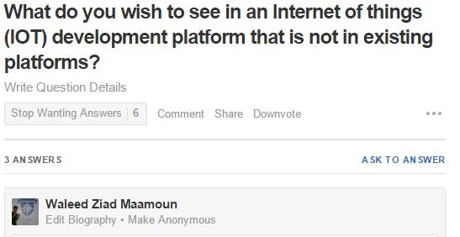

Figure ‎2.1. Question Asked on Quora

Below are some of the answers by people who are experienced in the field.

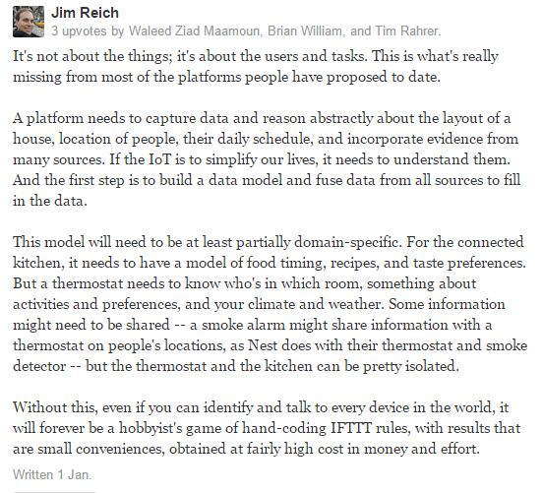

Figure ‎2.2. Answer by Jim Reich on Quora

- Jim Reich

Researcher at Carnegie Mellon University

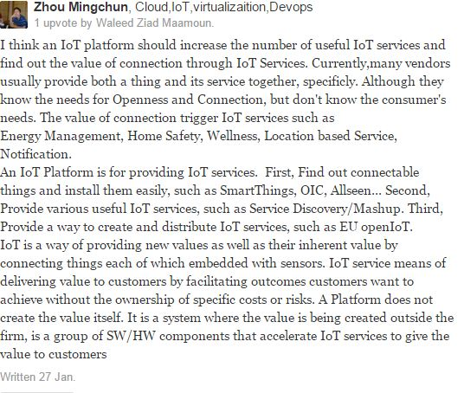

Figure ‎2.3. Answer by Zhou Mingchun on Quora

- Zhou Mingchun

IOT Expert at Samsung Electronics

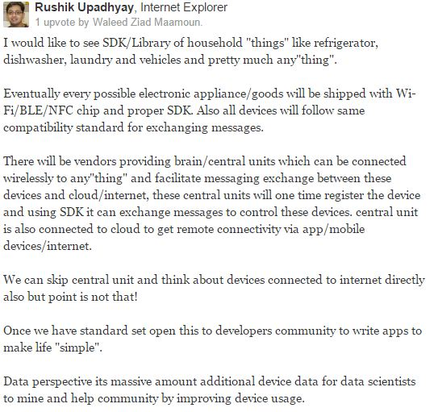

Figure ‎2.4. Answer by Rushik Upadhyay on Quora

- Rushik Upadhyay

PayPal

### Study

In 2011 there was estimated a number of 9 billion total connected devices to the internet, 6 billion of those were mobile connected devices. In 2020 those numbers are estimated to be 24 billion total connected devices, 12 billion of which are mobile connected devices which makes the revenue opportunity for mobile network operators in 2020 $1.2 trillion which is a 7 times increase on 2011 expected revenue. Also the revenue opportunity for connected devices in vertical sectors such as automotive, health, computer electronics and utilities are $202 billion, $69 billion, $445 billion and $36 billion respectively as shown in figure 2.5.

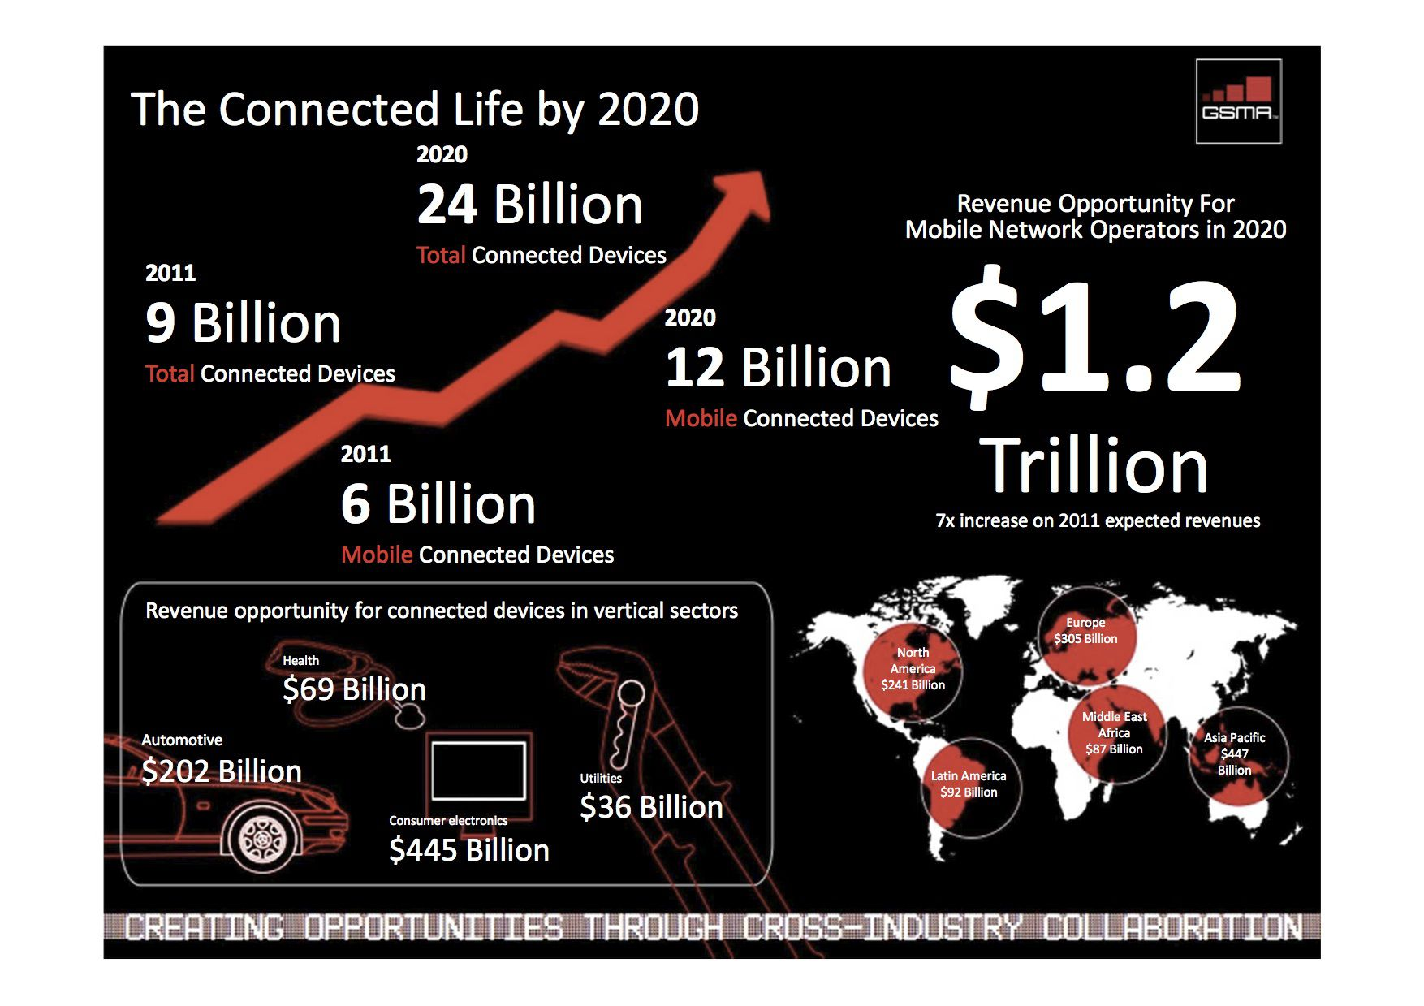

Figure ‎2.5. Mobile Connected Devices Study

## Analysis

### Hardware: Raspberry Pi

The Raspberry Pi is a low cost, credit card sized computer that plugs into any normal TV or monitor. It enables people to explore computing, whether they are old, middle aged or young. It can also be used to teach computer programming which uses special computer languages such as Scratch and Python. Raspberry Pi came from the idea that, without an affordable solution, children of the future would grow up without being computer literate in the new age of technology.

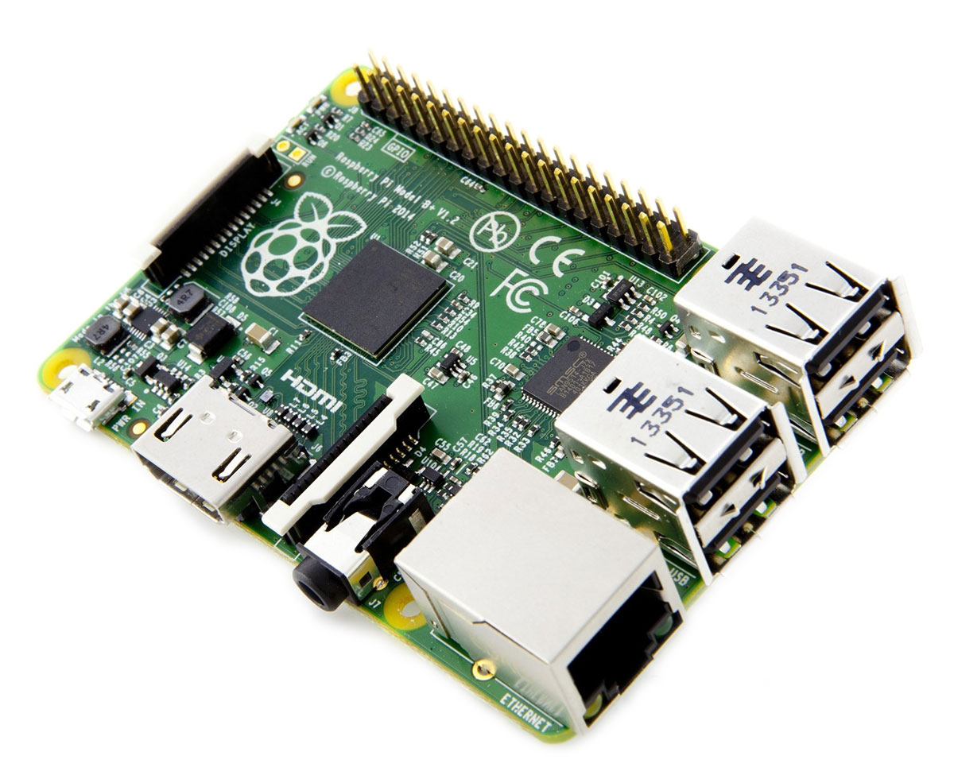

Figure ‎2.6. Raspberry Pi

What you can do with the Raspberry Pi vastly outweighs what you can’t do. The possibilities are practically endless. From something as simple as using it as normal computer with an office package and an internet browser to making your own retro games console. The GPIO (General-purpose input/output) terminals can be used in the same vein as a switch to turn objects on and off or even using it as a quick reaction game.

#### Raspberry Pi Specifications

|  |  |
| --- | --- |
| Specification |  |
| CPU | Broadcom BCM2835 SOC 700MHz |
| GPU | Broadcom VideoCore IV |
| Memory | 512 MB (shared with GPU) |
| USB | 2 x USB 2.0 |
| Video | Phono (RCA), HDMI (up to 1.4 compatible) and DSI socket |
| Audio | 3.5 mm jack |
| Storage | SD card slot |
| Network | 10/100 Mb/s |
| Power | Micro USB DC 5 V @ 800 mA for the Pi board |
| Dimensions | 85.6 mm x 53.98 mm |
| Operating Software | Supplied with Raspbian |
| I/O | 26 pin GPIO customisable pin array |
| Package Contents |  |
|  | Raspberry Pi Model B board |
|  | Wi-Fi Dongle |
|  | USB Keyboard |
|  | USB Mouse |
|  | 4 Port USB Hub |
|  | 2 Port USB PSU @ 2.1A |
|  | Micro USB Cable |
|  | SD Card with Raspbian OS pre-installed |

### Technologies Used

#### Raspberry Pi

Mentioned in the previous section.

#### Java EE

Java Platform, Enterprise Edition or Java EE is Oracle's enterprise Java computing platform. The platform provides an API and runtime environment for developing and running enterprise software, including network and web services, and other large-scale, multi-tiered, scalable, reliable, and secure network applications. Java EE extends the Java Platform, Standard Edition (Java SE), providing an API for object-relational mapping, distributed and multi-tier architectures, and web services.

#### Spring MVC

The Spring Web model-view-controller (MVC) Framework is an application framework and inversion of control container for the Java platform. The framework's core features can be used by any Java application, but there are extensions for building web applications on top of the Java EE platform. Although the framework does not impose any specific programming model, it has become popular in the Java community as an alternative to, replacement for, or even addition to the Enterprise JavaBeans (EJB) model.

#### Hibernate

Hibernate ORM (Hibernate in short) is an object-relational mapping framework for the Java language, providing a framework for mapping an object-oriented domain model to a traditional relational database. Hibernate solves object-relational impedance mismatch problems by replacing direct persistence-related database accesses with high-level object handling functions.

Hibernate's primary feature is mapping from Java classes to database tables (and from Java data types to SQL data types). Hibernate also provides data query and retrieval facilities. It generates SQL calls and relieves the developer from manual result set handling and object conversion. Applications using Hibernate are portable to supported SQL databases with little performance overhead.

#### HTML

HyperText Markup Language, commonly referred to as HTML, is the standard markup language used to create web pages. It is written in the form of HTML elements consisting of tags enclosed in angle brackets (like <html>). HTML tags most commonly come in pairs like <h1> and </h1>, although some represent empty elements and so are unpaired, for example <img>. The first tag in such a pair is the start tag, and the second is the end tag (they are also called opening tags and closing tags).

Web browsers can read HTML files and render them into visible or audible web pages. Browsers do not display the HTML tags and scripts, but use them to interpret the content of the page. HTML describes the structure of a website semantically along with cues for presentation, making it a markup language, rather than a programming language.

HTML elements form the building blocks of all websites. HTML allows images and objects to be embedded and can be used to create interactive forms. It provides a means to create structured documents by denoting structural semantics for text such as headings, paragraphs, lists, links, quotes and other items. It can embed scripts written in languages such as JavaScript which affect the behavior of HTML web pages.

#### CSS

Cascading Style Sheets (CSS) is a style sheet language used for describing the look and formatting of a document written in a markup language. Although most often used to change the style of web pages and user interfaces written in HTML and XHTML, the language can be applied to any kind of XML document, including plain XML, SVG and XUL. Along with HTML and JavaScript, CSS is a cornerstone technology used by most websites to create visually engaging webpages, user interfaces for web applications, and user interfaces for many mobile applications.

#### JavaScript

JavaScript is a dynamic programming language. It is most commonly used as part of web browsers, whose implementations allow client-side scripts to interact with the user, control the browser, communicate asynchronously, and alter the document content that is displayed. JavaScript is also considered an "assembly language of the web" – a compile target of source-to-source compilers – for making client side web applications, using other programming languages, supported by all the major browsers without plug-ins. It is also used in server-side network programming with runtime environments such as Node.js, game development and the creation of desktop and mobile applications.

#### Mosquitto

Mosquitto is an open source message broker that implements the MQ Telemetry Transport protocols. MQTT provides a lightweight method of carrying out messaging using a publish/subscribe model. This makes it suitable for "machine to machine" messaging such as with low power sensors or mobile devices such as phones, embedded computers or microcontrollers.

#### JPA

The Java Persistence API (JPA) is a Java application programming interface specification that describes the management of relational data in applications using Java Platform, Standard Edition and Java Platform, Enterprise Edition.

Main features of JPA are expanded object-relational mapping functionality, support for collections of embedded objects linked in the ORM with a many-to-one relationship, ordered lists, combinations of access types, a criteria query API, standardization of query 'hints', standardization of additional metadata to support DDL generation, support for validation and shared object cache support.

#### Eclipse Paho

Eclipse is an integrated development environment (IDE). It contains a base workspace and an extensible plug-in system for customizing the environment. Written mostly in Java, Eclipse can be used to develop applications. By means of various plug-ins, Eclipse may also be used to develop applications in other programming languages: Ada, ABAP, C, C++, COBOL, Fortran, Haskell, JavaScript, Lasso, Lua, Natural, Perl, PHP, Prolog, Python, R, Ruby (including Ruby on Rails framework), Scala, Clojure, Groovy, Scheme, and Erlang. Development environments include the Eclipse Java development tools (JDT) for Java and Scala, Eclipse CDT for C/C++ and Eclipse PDT for PHP, among others.

The Paho project provides open-source client implementations of MQTT and MQTT-SN messaging protocols aimed at new, existing, and emerging applications for Machine‑to‑Machine (M2M) and Internet of Things (IoT).

#### Embedded Linux

The Linux kernel is a Unix-like computer operating system kernel. The Linux kernel is a widely used operating system kernel world-wide; the Linux operating system is based on it and deployed on both traditional computer systems, usually in the form of Linux distributions, and on embedded devices such as routers. The Android operating system for tablet computers and smartphones is also based atop the Linux kernel.

Operating systems based on the Linux kernel are used in embedded systems such as consumer electronics and mobile devices that are actually touchscreen-based embedded devices, such as smartphones and tablets, together with personal digital assistants (PDAs) and portable media players that also include a touchscreen.

#### Adobe Dreamweaver

Adobe Dreamweaver is a web design and development application that provides a visual WYSIWYG editor (colloquially referred to as the Design view) and a code editor with standard features such as syntax highlighting, code completion, and code collapsing as well as more sophisticated features such as real-time syntax checking and code introspection for generating code hints to assist the user in writing code. The Design view facilitates rapid layout design and code generation as it allows users to create and manipulate the layout of HTML elements. Dreamweaver features an integrated browser for previewing developed webpages in the program's own preview pane in addition to allowing content to be open in locally installed web browsers. It provides transfer and synchronization features, the ability to find and replace lines of text or code by search terms or regular expressions across the entire site, and a templating feature that allows single-source update of shared code and layout across entire sites without server-side includes or scripting.

### Existing Products

#### Xively

Xively is a division of LogMeIn Inc., a global, public company that provides remote access and collaboration products including Rescue, Boldchat, join.me, and Cubby. Xively by LogMeIn offers an Internet of Things (IoT) platform as a service, business services, and partners that enable businesses to quickly connect products and operations to the Internet.

Figure ‎2.7. Xively Logo

#### https://tctechcrunch2011.files.wordpress.com/2015/05/particle.pngParticle

Particle (formerly known as Spark) offers a suite of hardware and software tools to help the user prototype, scale, and manage your Internet of Things products.

With Particle, the user's prototype is backed up by a real-time, secure and scalable cloud platform. The cloud platform will support your first product to your one millionth product, with our low-cost hardware modules providing a simple connection to the cloud at scale.

Figure ‎2.8. Particle Logo

# **Chapter 3**

**Requirements**

**And Design**

*“Without requirements or design, programming is the art of adding bugs to an empty text file.”*

*- Louis Srygley*

*Software Architect, UPS*

# Requirements and Design

## Introduction

### Product Overview

Our product is an Internet of things development platform that ease the process of development application using the internet of things concept and abstracts a lot of work needed so that the developer would concentrate on the functionality of his app only.

## Specific Requirements

### External Interface Requirements

#### User Interfaces

1) A welcome screen with explanation of the project and some images to illustrate and links to other screens.

2) A login screen where the user is going to provide his user name and password to proceed to his account with a link to a forget password page.

3) Forget password page where he enters his mail and a send button

4) A sign up page where the user is going to provide his information to create a new account for him

5) After logging in the user is going to be shown his dashboard, a page where he can see how many device is connected last time each device sent anything and other details about his usage

6) When clicking on every device a page is shown for every device showing the data the device have sent statistics about the data the average and so in and some graphing about the data sent and links to the firmware code running on the device and the cloud code, when clicking on any of them it expands to show the code when the user press edit an instance of the web IDE is shown with code inside of it

7) The IDE page a text editor is shown in the left, a small window with folder view of files and folders below it a set of buttons which is {Run , Stop , Deploy } and then in the bottom center a window of output where the output of the code is viewed.

#### Hardware Interfaces

##### Device Side

Our target hardware device side is TI CC 3200 which is a microprocessor (ARM® Cortex®-M4 Core at 80 MHz) with a built in WiFi Receiver which is ideal for Internet of things applications.

##### Server Side

Cloud code and data will run on server side on an average computer so it has no specific hardware interface and all hardware communications are managed by the underlying operating system on the web server.

#### Software Interfaces

The device code communicates with web server to send him data acquired and status and the server communicates with device code to send it commands or updated codes the server side code deals with REST requests to provide data and deals with DBMS to insert or update data in the database

#### Communication Protocols

The device is going to communicate with the web server using encrypted MQTT protocol on top of TCP/IP, the server is going to deal with client side using standard HTTP and deal with REST calls using HTTPs.

### Software Product Features

#### Functional Requirements

##### User Login

The user should be able to login with his user name and password to the system

##### User Sign Up

The user should be able to create a new account while providing information like name, email and password.

##### User Forget Password

The user should enter his mail and the password be reset and sent to his mail.

##### Connect Devices

The user should be able to connect to his devices and the system should provide him with a unique API key that the device can send to so the system would know which user belongs to this device.

##### Accept Data

The system should be able to accept data from the devices and store it for each user.

##### Showing Data

The system should provide the user with the data in tables.

##### Graphing Data

The system should provide different graphing according to the data types

##### Device Status

The system should provide the user with information about the status of the device including last time it sent , how many times it sent data , the time of every time data was sent , graph with these attributes

##### More Than One Device

The system should allow the users to have more than one connected device

##### Rest API

The system should have a rest API so that the user can hit the server and obtain his data

##### JS Library

A library would be made in Java script that handles REST and API calls that can be embedded in the developer code to ease the process of communicating with the System.

##### Online IDE

There should be an online IDE that the user can write different kinds of code in it.

##### Online IDE - 2

The IDE should have the basic features of a basic IDE like having a text editor, running code, stopping, deploying.

##### Server Side Code

The system should allow the user to write code that runs in the cloud based that can be triggered when his data arrives and the Rest API should handles how he gets his output the target language would be Java with a room for extension afterwards.

##### Flashing Code Remotely

The system should allow the user to write device code and flash it remotely to his device.

##### Device Library

In order for the device to be able el be flashed remotely a library should be developed to allow this to happen.

##### Real Time Data

All the data sent must be handled and processed in real time as the type of applications running would be time critical.

##### Real Time Data - 2

In order for data to be real time the application protocol to be used is MQTT.

##### MQTT (Device)

To be able to provide MQTT a library should be developed on the device so that data can be sent using this protocol.

##### Device Library - 2

In order for the server to deal with MQTT the server should have the right message broker to handle messages being sent.

### Software System Attributes

#### Reliability

The system should be reliable as in server must not crash and must be available all the time as developer applications rely on it , also data should have a backup in case any kind of damage happens

#### Security

The system of course must be secure as the data it contains is very critical and security is going to be achieved through:

1) Encrypting communication between the device and the server RSA and AES

2) Encrypting communication between server and client using SSL/TLS.

#### Maintainability

The System should be maintainable as in the future it can support languages other than java easily, also the library can have other targeted hardware so the cost of change should be minimal.

#### Performance

The library should be highly optimized and have the least footprint as possible so that there would be room for developers application specially with the limited resources of embedded devices so the library shouldn’t take more than 20% of processor time.

### Database Requirements

The database targeted would be MySQL but should have plans in the future for no SQL database like MongoDB so code dealing with database should be highly extendable.

## Architectural Design

### Introduction

Our product is an Internet of things development platform that ease the process of development application using the internet of things concept and abstracts a lot of work needed so that the developer would concentrate on the functionality of his app only.

### Architectural Representation

This document details the architecture using the views defined in the “4+1” model, but the views used to document the Internet of things platform application are:

##### Use Case View

Audience: All the stakeholders of the system, including the end-users.

##### Logical View

Audience: Designers.

##### Process View

Audience: Integrators.

##### Module Decomposition View

Audience: Programmers.

##### Data View

Audience: Data specialists, Database administrators

### Architectural Goals and Constraints

##### Server Side

IOTA will be hosted on one of Apache web servers running on a Java platform, and connecting to one of the MySQL Database servers. All communication with client has to comply with public HTTPS, MQTT , TCP/IP communication protocol standards.

##### Client Side

Users will be able to access IOTA only online. Clients/users are requiring using a modern web browser such as Mozilla or Chrome

##### Device Side

IOTA Libraries will be running on RTOS named “RTEMS” with portability options in any ARM Architecture board but target hardware which these libraries will be tested is “TI CC 3200”

#### Security

User’s devices can only be accessed , updated or removed by the users who created it , all communications with devices and server will be secured and cannot be sniffed or altered.

#### Persistence

Data persistence will be addressed using a relational database.

#### Performance

The system should respond to the user in a real time way meaning that the level of server responsiveness that a user senses as sufficiently immediate or that enables the server to keep up with some external process such as change in sensor reading value.

### Use-Case View

This is a list of use-cases that represent major functionality of the final system

* Sign up for the user
* Login for the user
* Create a new device
* Read data sent from device
* Write server code
* Deploy firmware code in device
* Deal with the system in “programmatic” way
* Send data from device to server
* Receive firmware updates from server to device

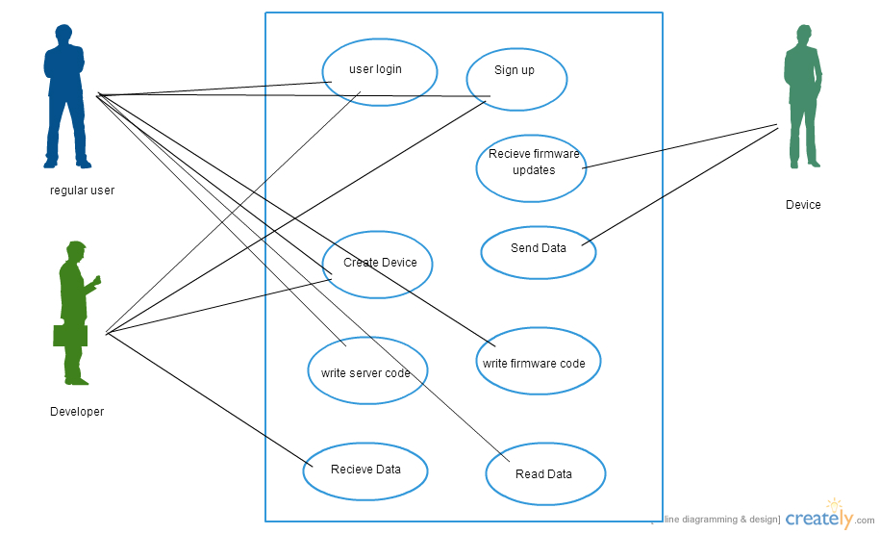

Figure ‎3.1. Use Case View

#### Actors

As described in the actors’ correspondence diagram below, web user could be one of three types.

##### Regular User

The user who can create a device, receives data from them, write server code or deploy firmware code.

##### Developer

A special type of user who can do all the user roles but in programmatic way so that he can embed it in his application.

##### Device

The device that sends data to the server and receives firmware updates from server.

### Logical View

IOTA is divided into layers based on the N-tier architecture

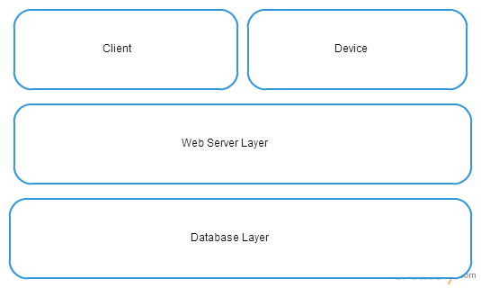

Figure ‎3.2. IOTA Logical View

### Process View

The process view depicts those activities that the system passes through when it exchanges messages with other systems. Purely technical processes that are necessary for communication between systems, such as dial-up or other connection to the Internet, are not the subject of the process view of our model.

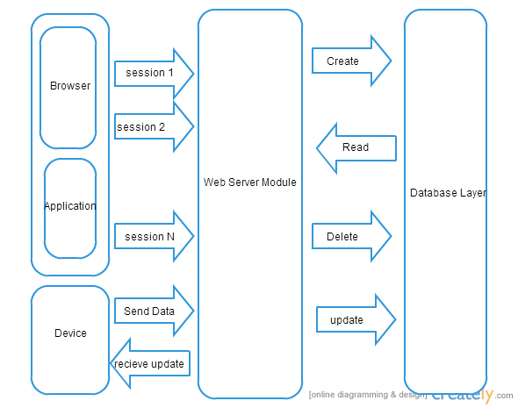

Figure ‎3.3. IOTA Process View

### Module Decomposition View

The modular decomposition is a decomposition of a graph into subsets of vertices called modules. A module is a generalization of a connected component of a graph. Unlike connected components, however, one module can be a proper subset of another. Modules therefore lead to a recursive (hierarchical) decomposition of the graph, instead of just a partition.

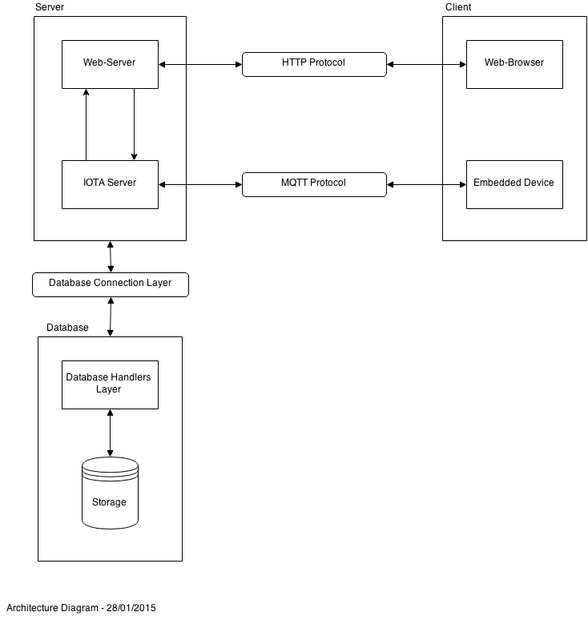

Figure ‎3.4. IOTA Module Decomposition View

### Database Design

Database design is the process of producing a detailed data model of a database. This logical data model contains all the needed logical and physical design choices and physical storage parameters needed to generate a design in a data definition language, which can then be used to create a database. A fully attributed data model contains detailed attributes for each entity.

The term database design can be used to describe many different parts of the design of an overall database system. Principally, and most correctly, it can be thought of as the logical design of the base data structures used to store the data. In the relational model these are the tables and view. In an object database the entities and relationships map directly to object classes and named relationships. However, the term database design could also be used to apply to the overall process of designing, not just the base data structures, but also the forms and queries used as part of the overall database application within the database management system (DBMS).

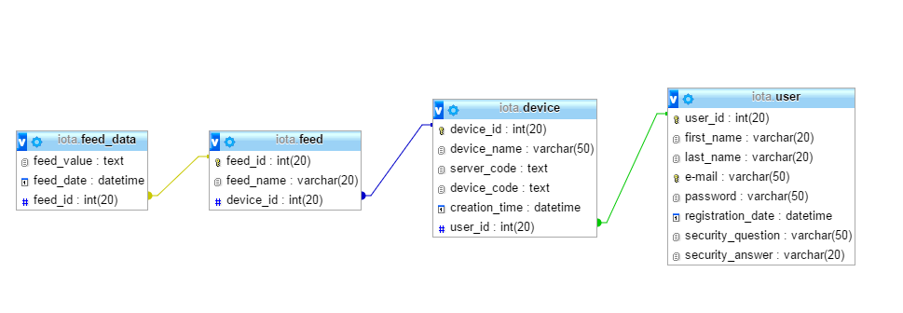

Figure ‎3.5. IOTA Data View

## Conceptual Design

### Experiential Flowchart

The Architectural Designs consists of three main parts

* The Server, consisting of
  + Web-Server
  + IOTA Server
* The Client, consisting of
  + Web-Browser
  + Embedded Device
* The Database, consisting of
  + Database Handlers Layer
  + Storage

The Web-Server and the Web-Browser are connected through the HTTP Protocol and the IOTA Server and Embedded Device are connected through the MQTT Protocol. While the Server and the Database are connected through a Database Connection Layer as shown in figure 3.4.

### Implementation Plan

The Implementation Plan is the detailed listing of activities, expected difficulties, and schedules that are required to achieve the objectives of the strategic plan needed to accomplish the overall project.

##### Timeline

Figure ‎3.6. Implementation Plan Timeline

# **Chapter 4**

**Implementation**

*“Ideas are easy. Implementation is hard.”*

*- Guy Kawasaki*

*Silicon Valley Marketing Executive*

# Implementation

In this chapter we’ll be adding figures of various parts of the project, explaining what every part contains and what it does.

## Home Page

The home page consists of 5 main sections; home, about, login, sign up and contact us as shown in figure 4.1.

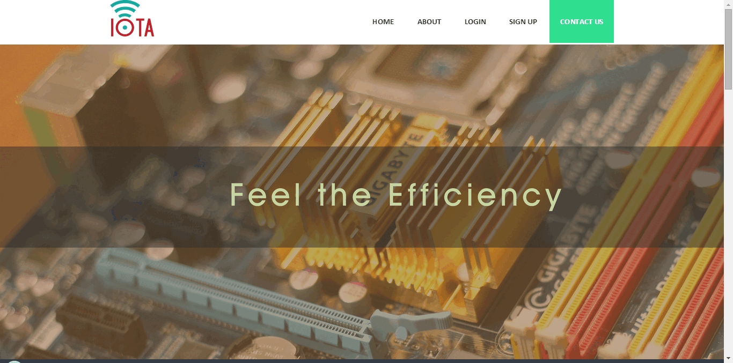

Figure ‎4.1. Home Page

### Home

Home consists of visuals regarding the product as well as info that is updated based on need as shown in figure 4.1.

### About

About contains info about the product and who we are as shown in figure 4.2.

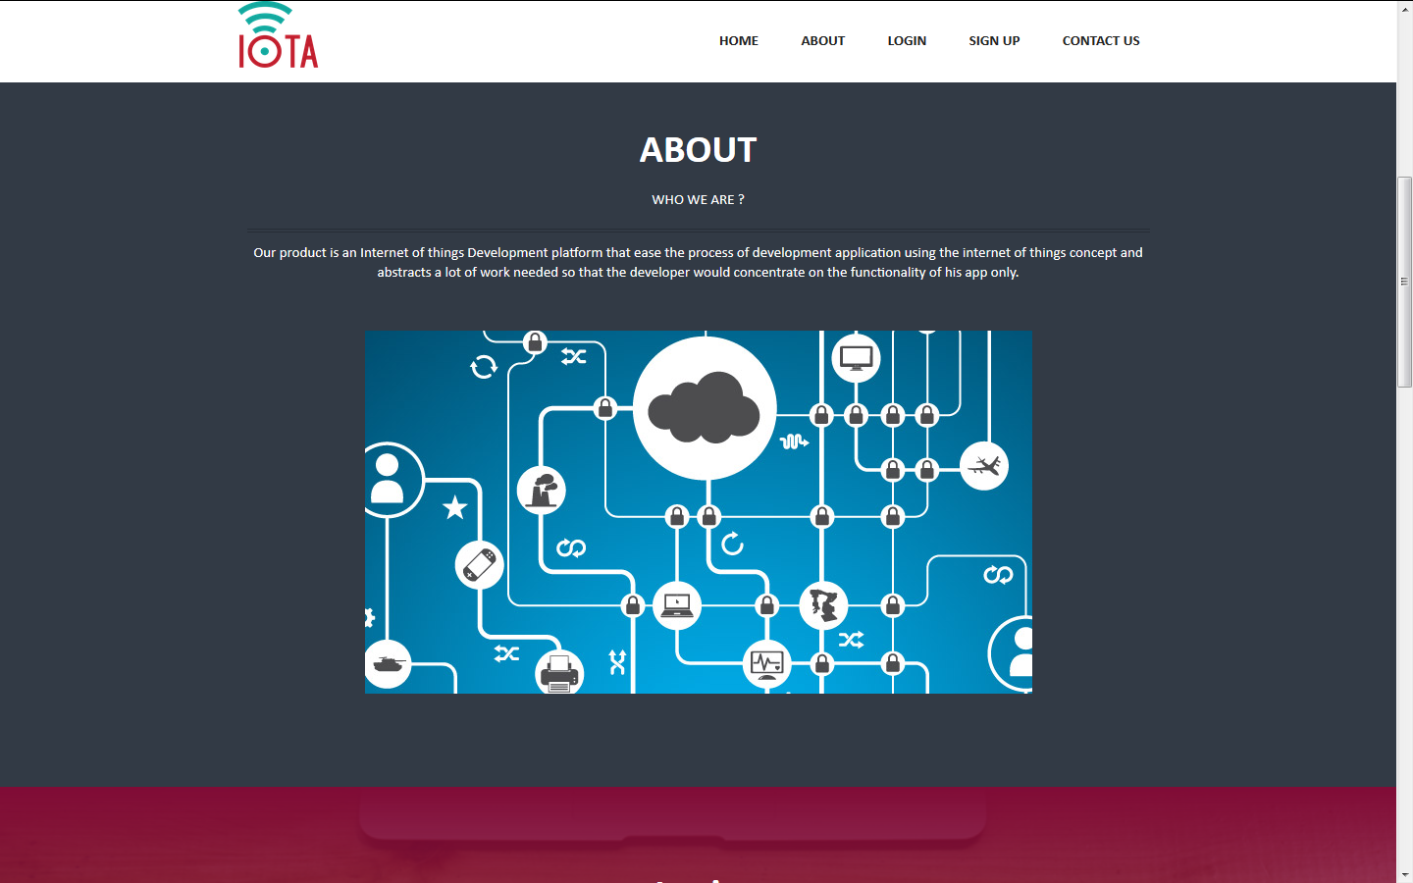

Figure ‎4.2. Home Page – About

### Login

The Login section contains a button as shown in figure 4.3 that redirects you to the login page shown in figure 4.4 where you’re asked to enter your previously registered email and password to be able to access the IOTA dashboard.

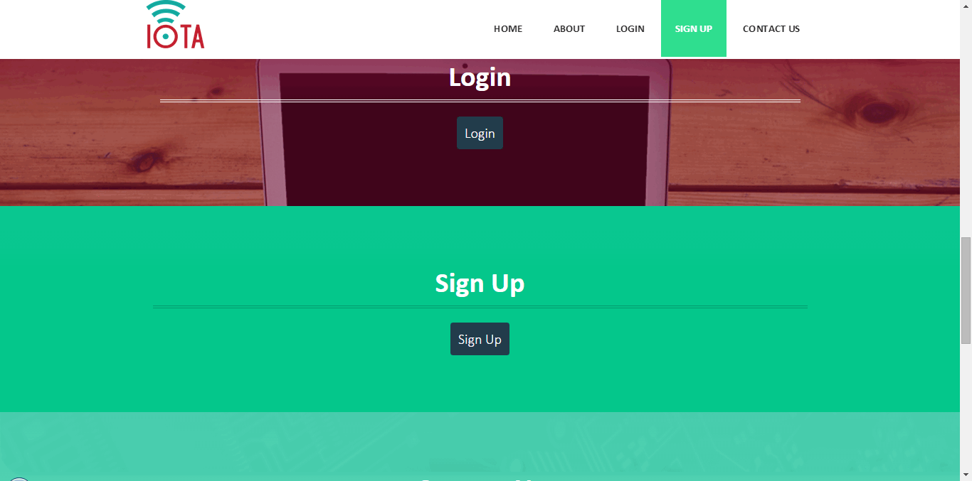

Figure ‎4.3. Home Page – Login and Sign Up

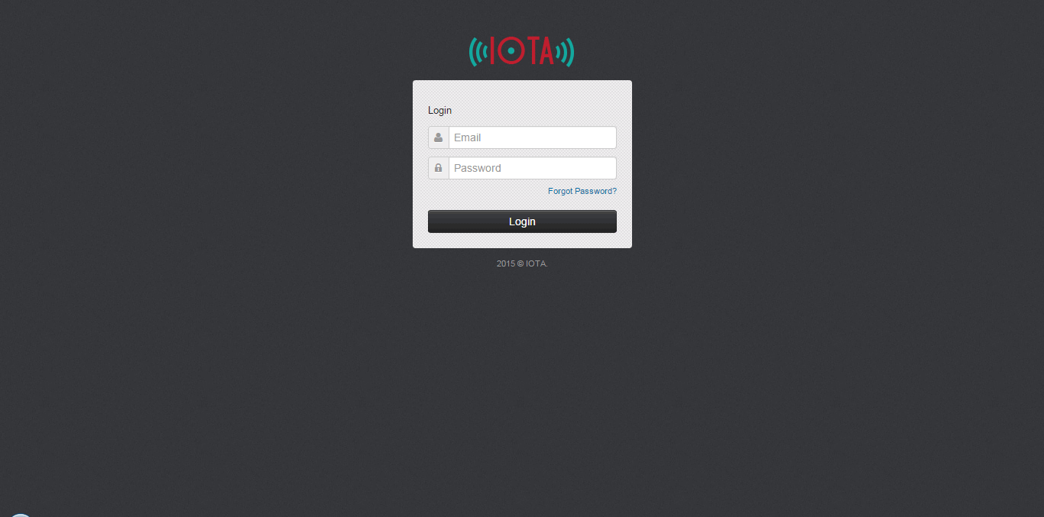

Figure ‎4.4. Login Page

There’s also a “Forgot Password?” link that redirects you to a page to retrieve your password as shown in figure 4.5 by entering your name in the specified field and then clicking on submit and you’ll be receiving the password on your email.

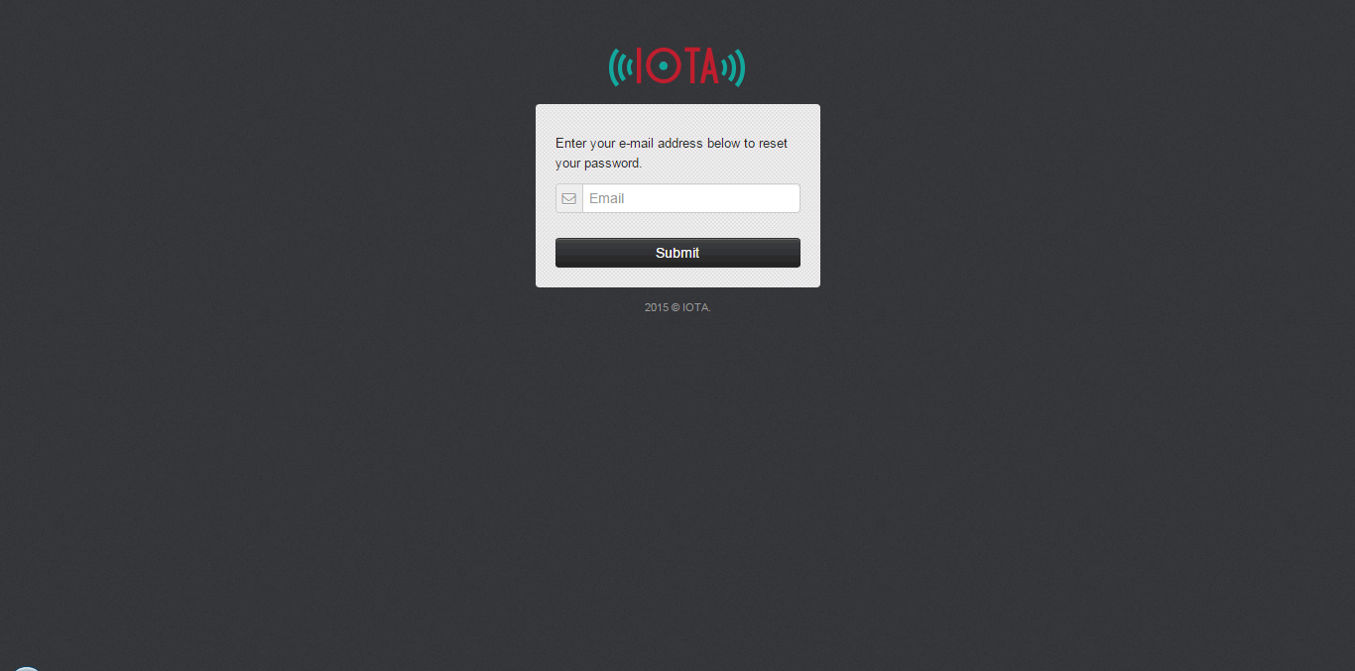

Figure ‎4.5. Forgot Password Page

### Sign Up

The Sign Up section contains a button as shown in figure 4.3 that redirects you to the sign up page shown in figure 4.6 where you can sign up a new account by filling the required field in the registration form which are your first name, last name, email, password and confirm password.

The registered email and password cab be used after that to login and access the IOTA dashboard.

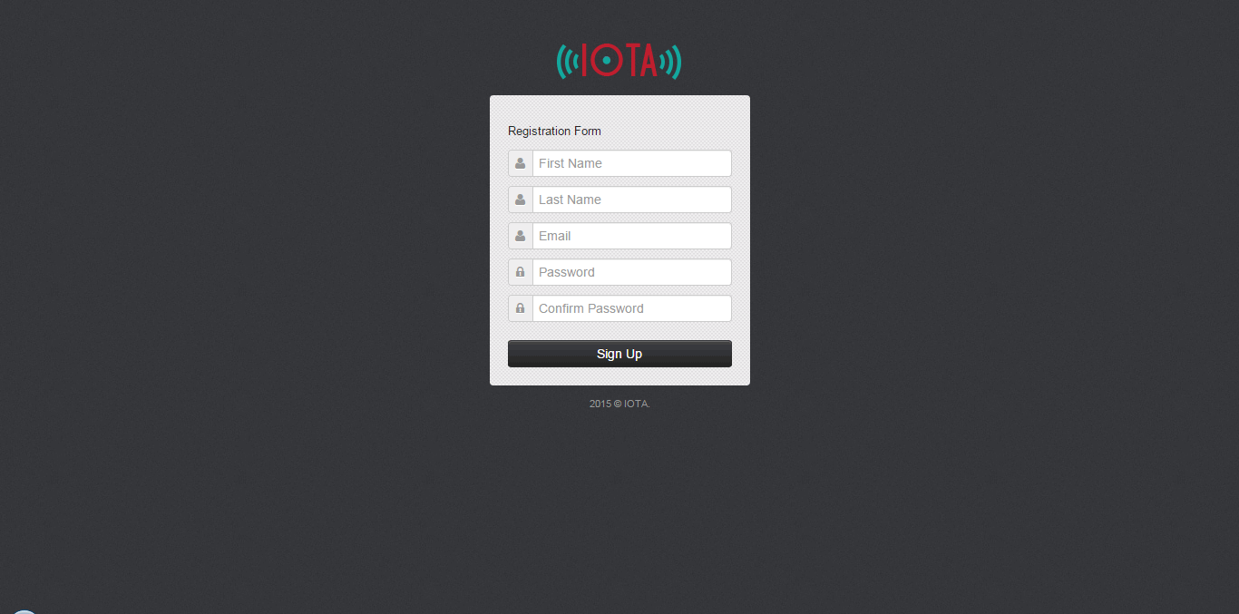

Figure ‎4.6. Sign Up Page

### Contact Us

The Contact Us section contains a form where you can contact the developers of the product with any comments, complaints or suggestions by entering your name, email address and message as shown in figure 4.7.

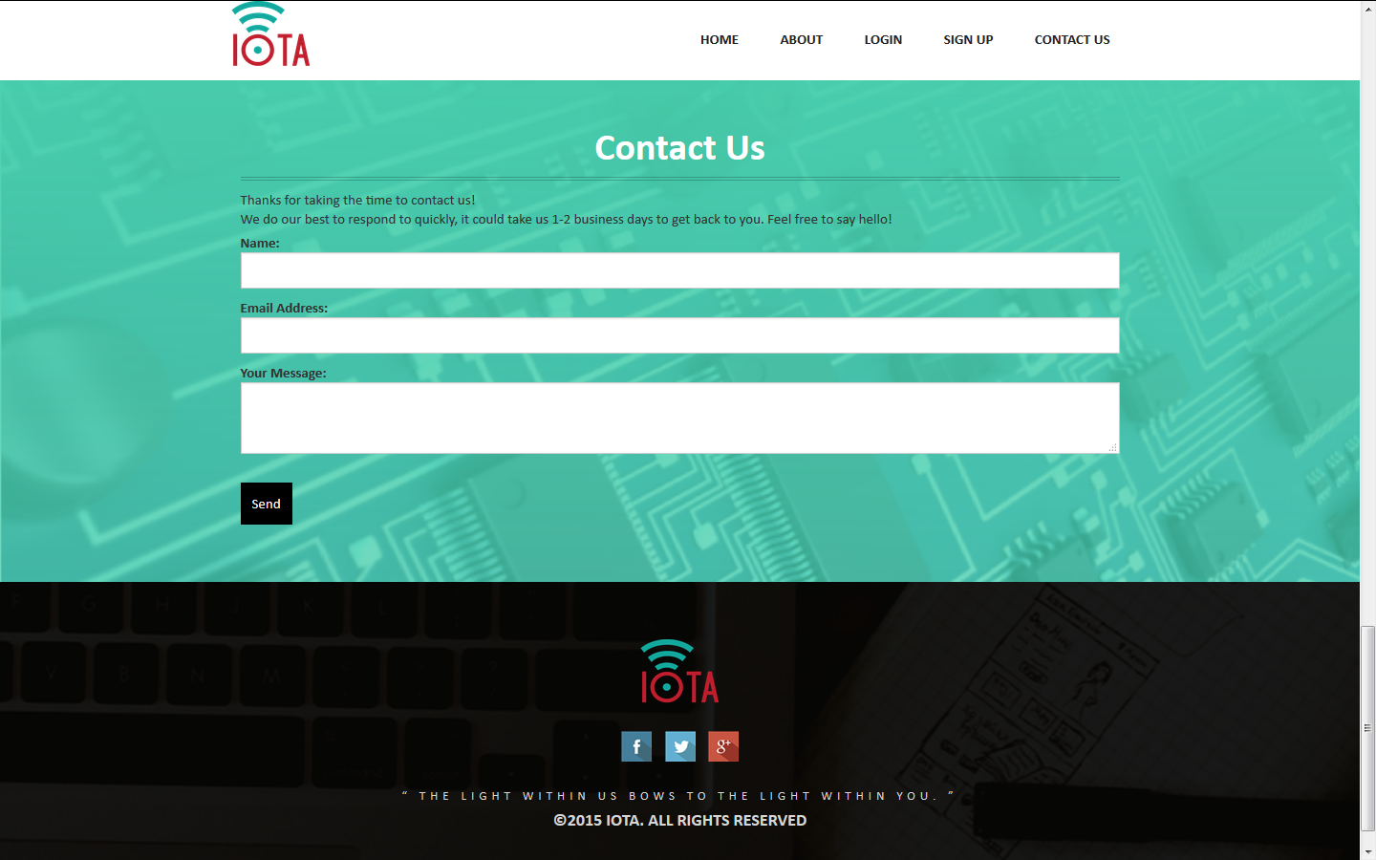

Figure ‎4.7. Home Page - Contact Us

## Dashboard

Once you login using a registered email and password, you’re redirected to the IOTA dashboard where you can add devices, feeds and monitor your devices.

The IOTA dashboard as shown in figure 4.8 contains a search bar and buttons to add devices and feeds at the top of the page. Below them you can monitor the already added devices and see statistics of the received feeds from these devices in the form of graphs.

In the upper right corner you can also view your account and you can log out at any time.

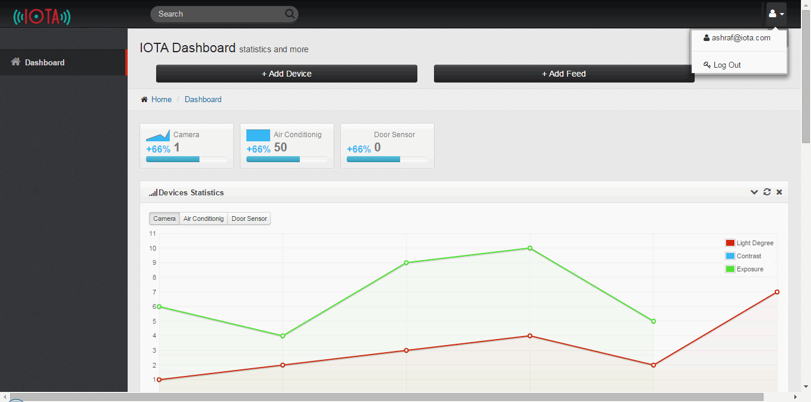

Figure ‎4.8. IOTA Dashboard

If you scroll down you can see the latest received feeds in a form of table where each entry in the table shows a received feed, the device that sent it, the feed name and its value as shown in figure 4.9.

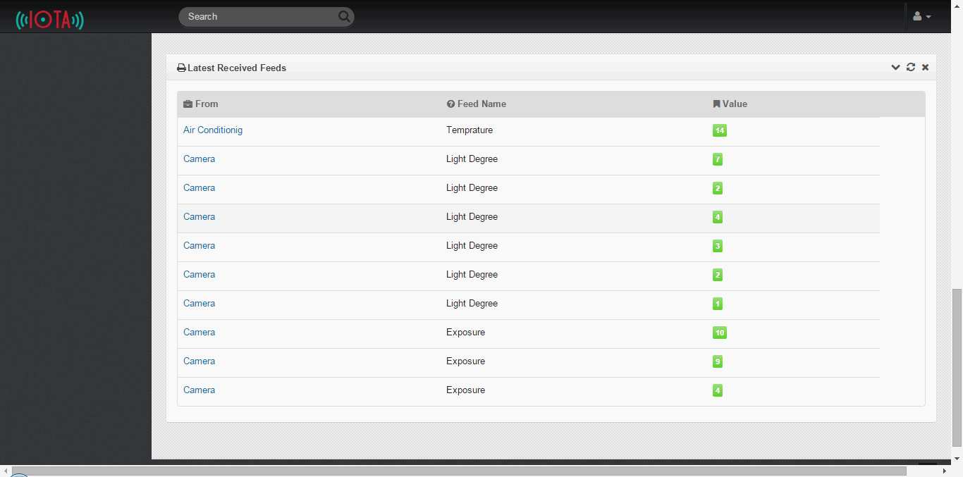

Figure ‎4.9. IOTA Dashboard - Received Feeds

You also have the option to change the style of the theme of the dashboard according to your need and what suits you as shown in figure 4.10.

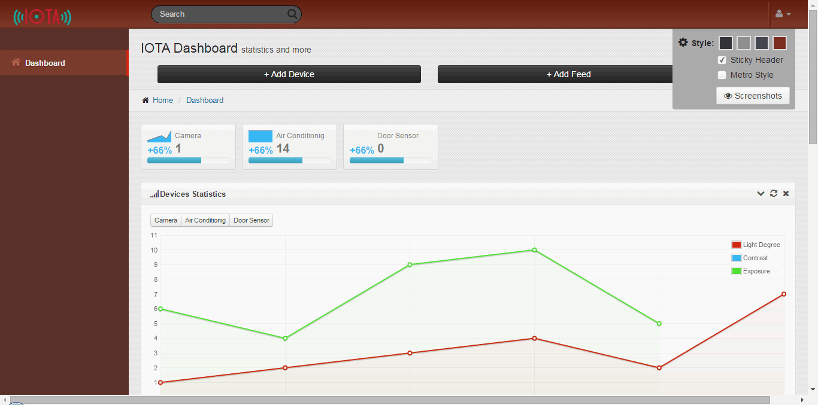

Figure ‎4.10. IOTA Dashboard Themes

### Add Device

If you click on the “Add Device” button found in the dashboard, you’ll be taken to the “Add Device” page as shown in figure 4.11 where you can add as many devices as you want by entering its name in the field and clicking on “Add Device”.

You can then return to the dashboard at any time by clicking on the “Dashboard” button.

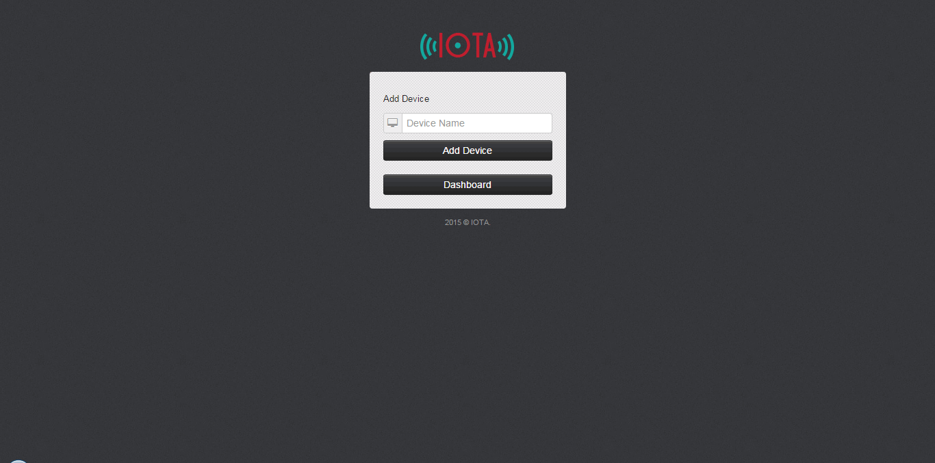

Figure ‎4.11. Add Device Page

### Add Feed

If you click on the “Add Feed” button found in the dashboard, you’ll be taken to the “Add Feed” page as shown in figure 4.12 where you can add as many feeds to each device as you want by selecting a device from the devices you already entered from the dropdown list and then entering the feed name in the field and clicking on “Add Feed”.

You can then return to the dashboard at any time by clicking on the “Dashboard” button.

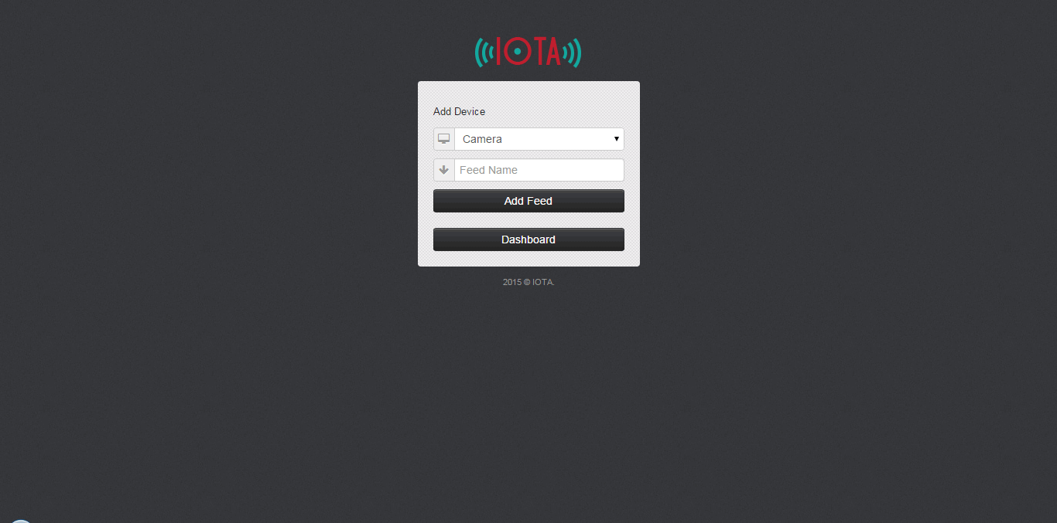

Figure ‎4.12. Add Feed Page

### Device Page

If you click on one of the devices that you have added on your dashboard, you’ll be redirected to the device page as shown in figure 4.13 which contains two buttons; the “Device IDE” button and the “Server IDE” button as well as statistics about the feed received from this particular device in the form of a graph.

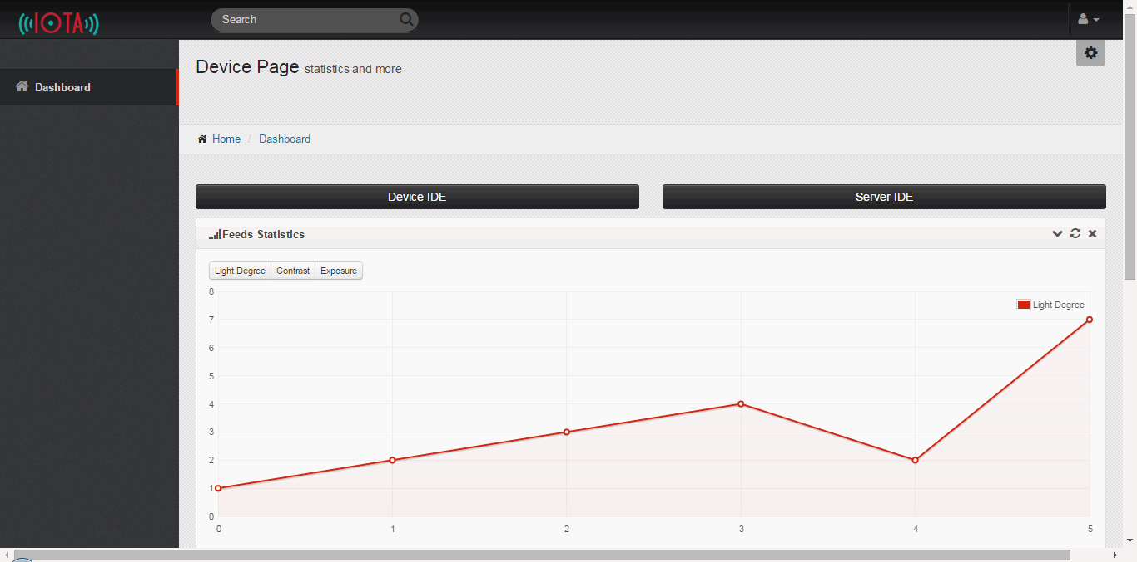

Figure ‎4.13. Device Page

If you scroll down you can see the device data in a form of table where each entry in the table shows a received feed, the device that sent it, the feed name and its value as shown in figure 4.14.

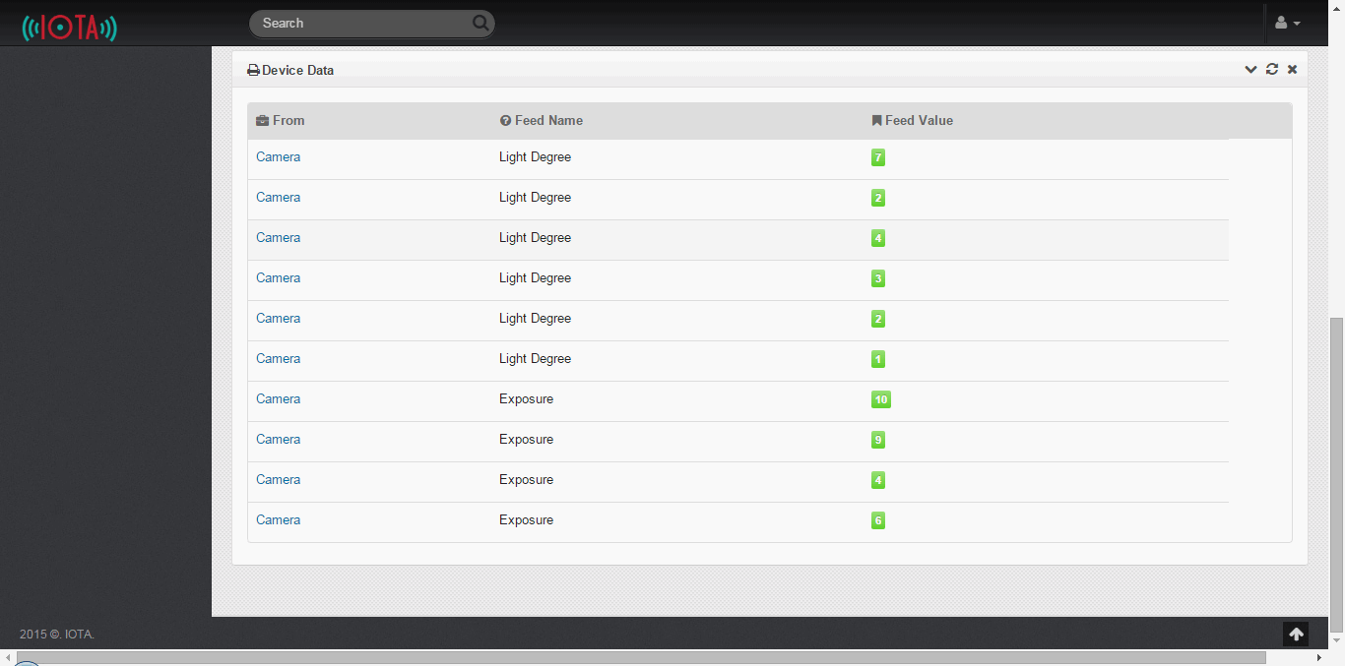

Figure ‎4.14. Device Data

### Device IDE

If you click on the “Device IDE” button found in the device page you’ll be redirected to the “Device IDE” page as shown in figure 4.15 where you can choose the preferred programing language from a dropdown list, write the code that you want to deploy on the device in the code editor and then you have the option to deploy and run the code by clicking on the “Deploy” and “Run” buttons and the result will be shown in the area below.

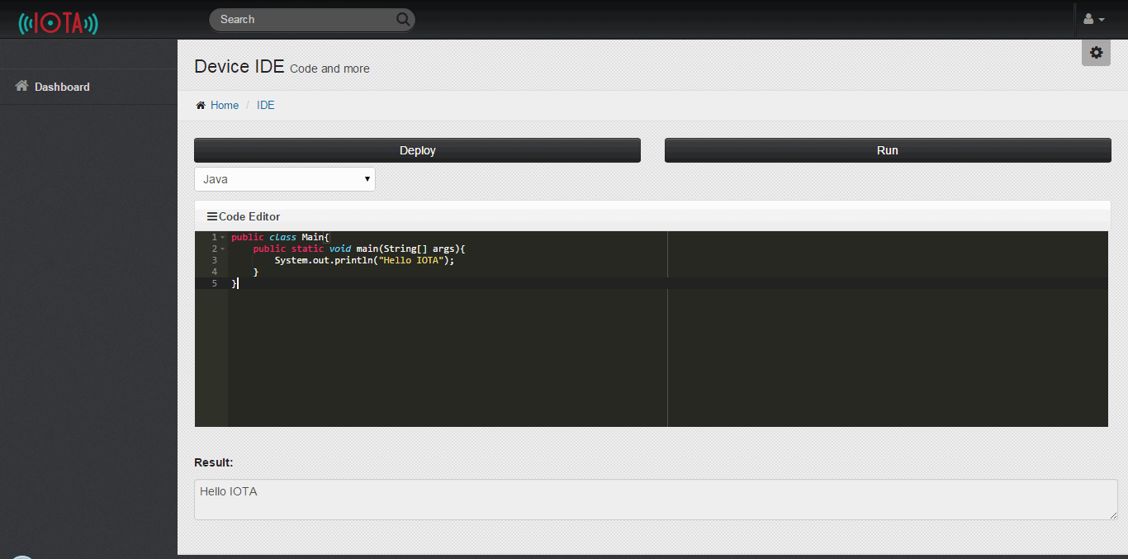

Figure ‎4.15. Device IDE Page

### Server IDE

If you click on the “Server IDE” button found in the device page you’ll be redirected to the “Server IDE” page as shown in figure 4.16 where you can choose the preferred programing language from a dropdown list, write the code that you want to deploy on the server in the code editor and then you have the option to deploy and run the code by clicking on the “Deploy” and “Run” buttons and the result will be shown in the area below.

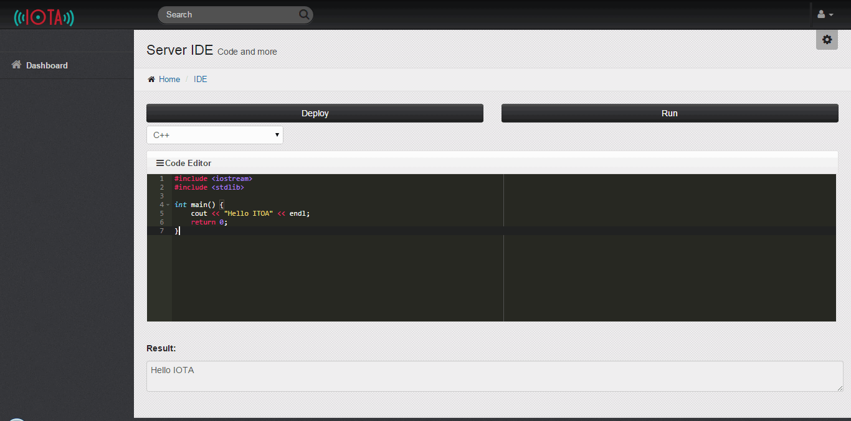

Figure ‎4.16. Server IDE Page

## Mobile Compatibility

IOTA is compatible with mobile devices, which makes it easier and more efficient as it can be accessed from anywhere using a cellphone or a tablet with internet connectivity as shown in the figures below

### Mobiles

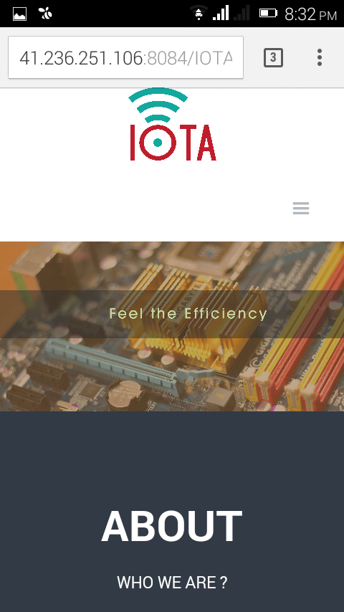 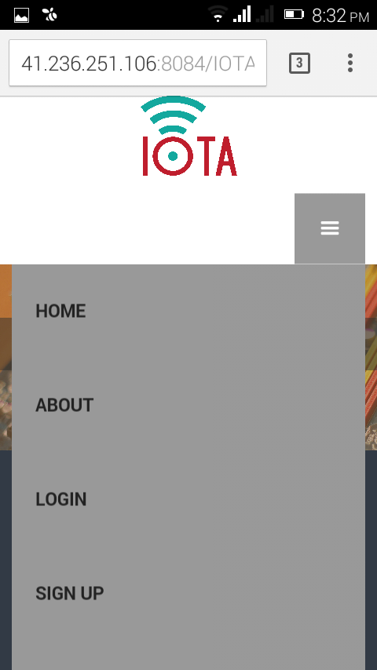 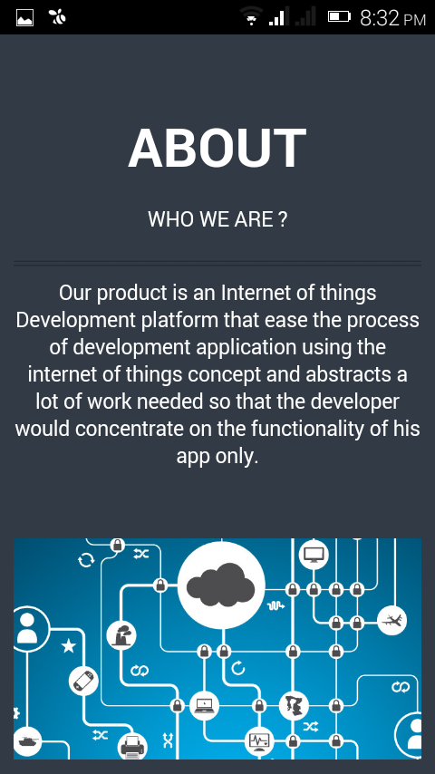 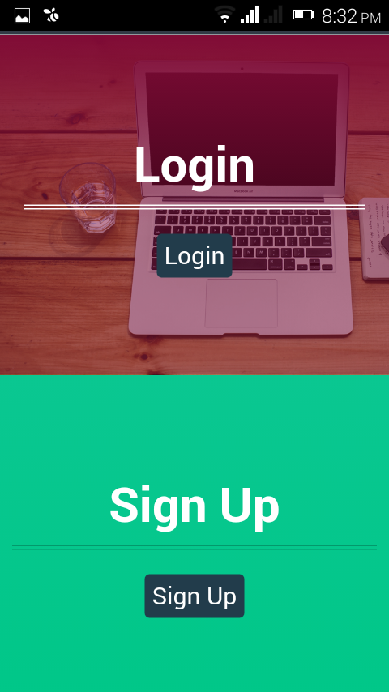 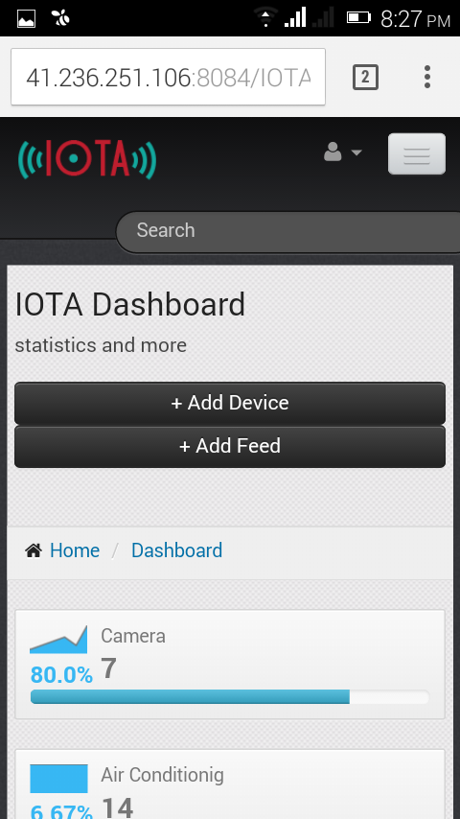 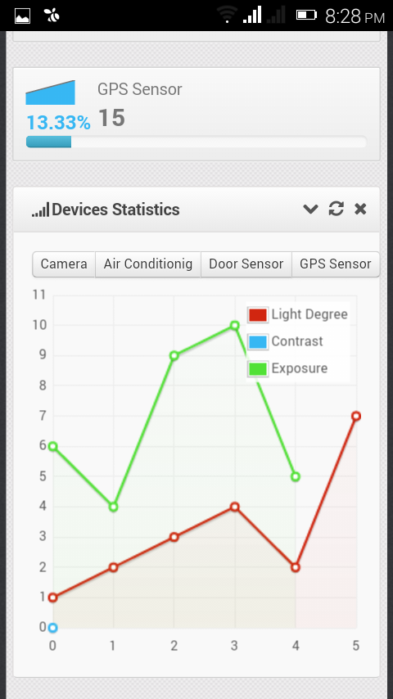 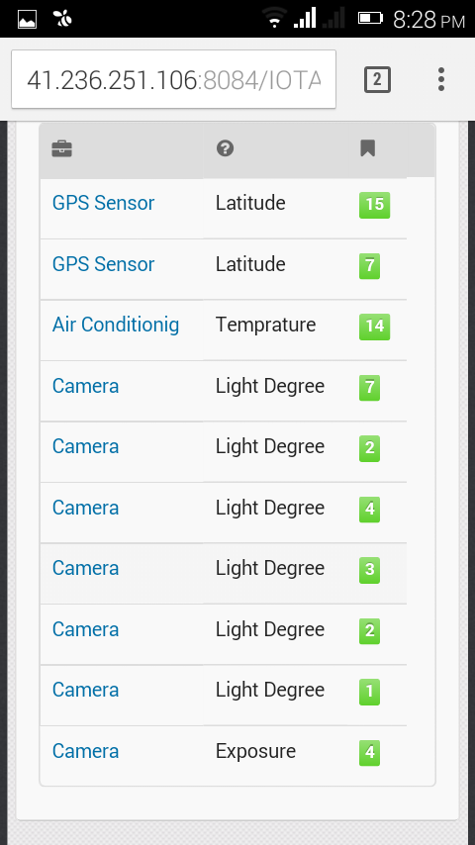 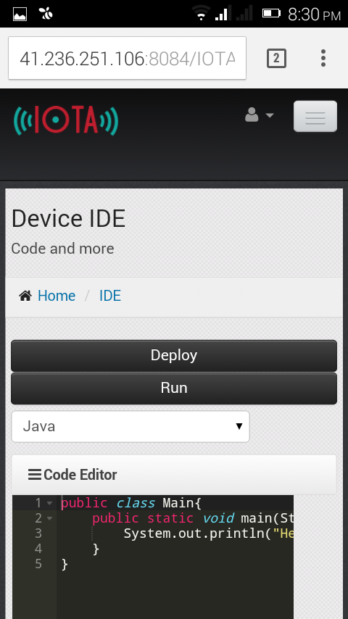

### Tablets

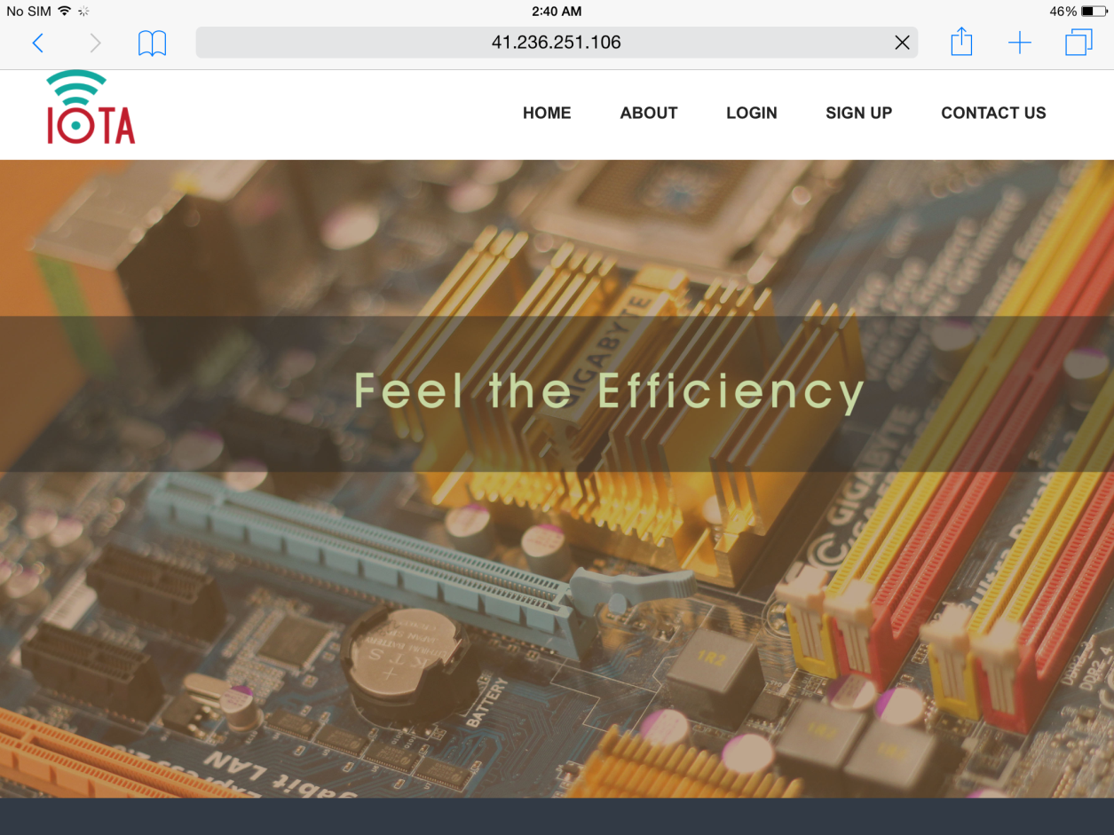

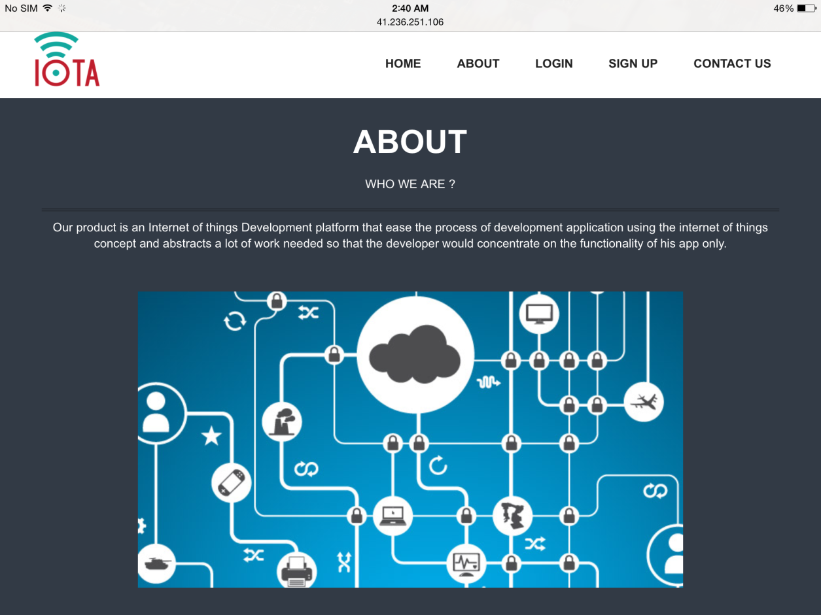 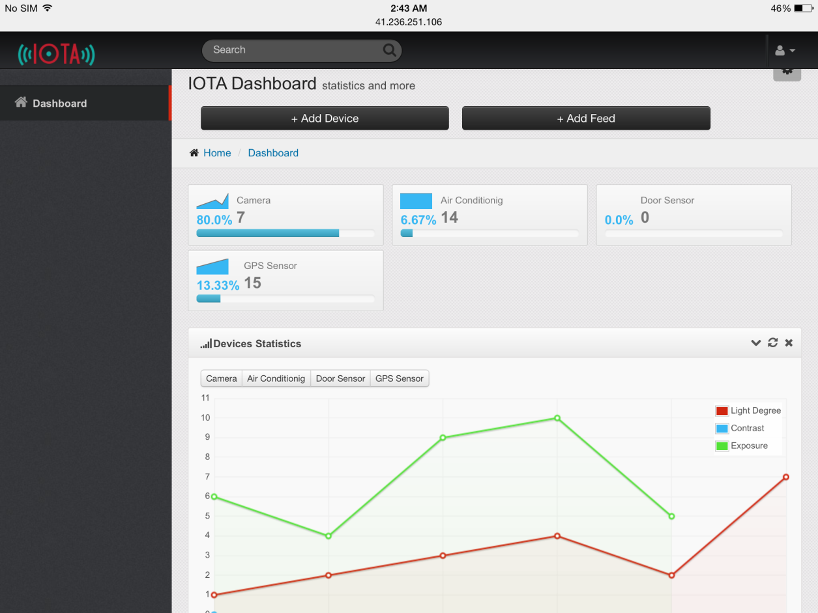 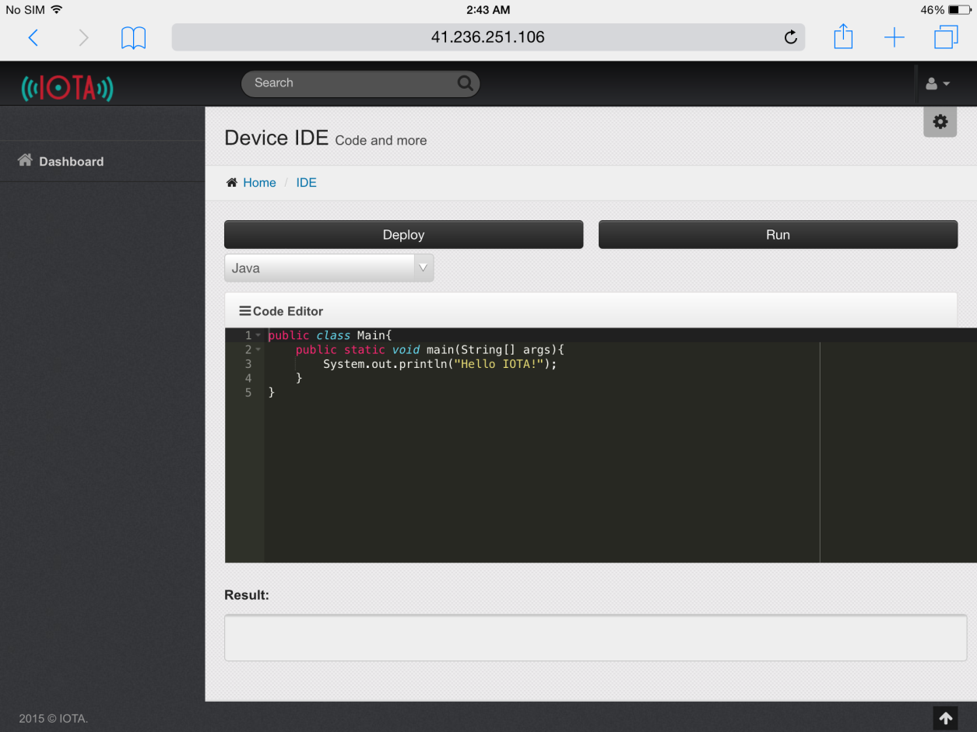

# **Chapter 5**

**Testing And**

**Conclusions**

*“If you don’t like testing your product, most likely your customers won’t like to test it either.”*

*- Anonymous*

# Testing and Conclusions

## Testing

### Home Navigation Test Cases

#### Test Case #1: Navigation

All the navigation in home page are working correctly you can navigate to Home, About, Login, Sign up and Contact us from the top bar in the home page you can see this in figure below:



Figure ‎5.1. Home Page Navigation

#### Test Case #2: Login Button

When click on login button it will redirect you successfully to the login section.

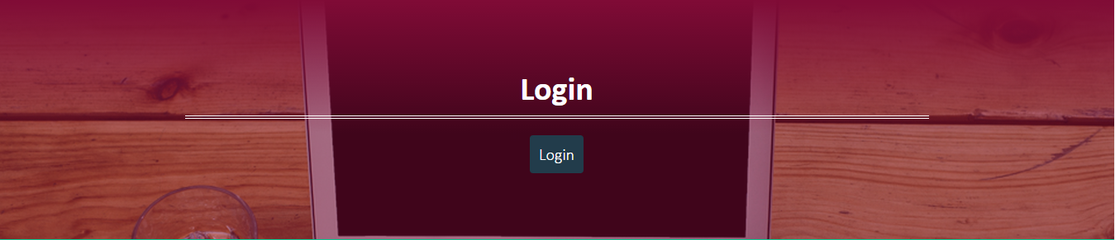

Figure ‎5.2. Home Page Login Section

#### Test Case #3: Sign Up Button

When click on sign up button it will redirect you successfully to the sign up section.



Figure ‎5.3. Home Page Sign Up Section

### Sign Up Test Cases

#### Test Case #1:Blank First Name

First Name field mustn’t be blank as shown below:

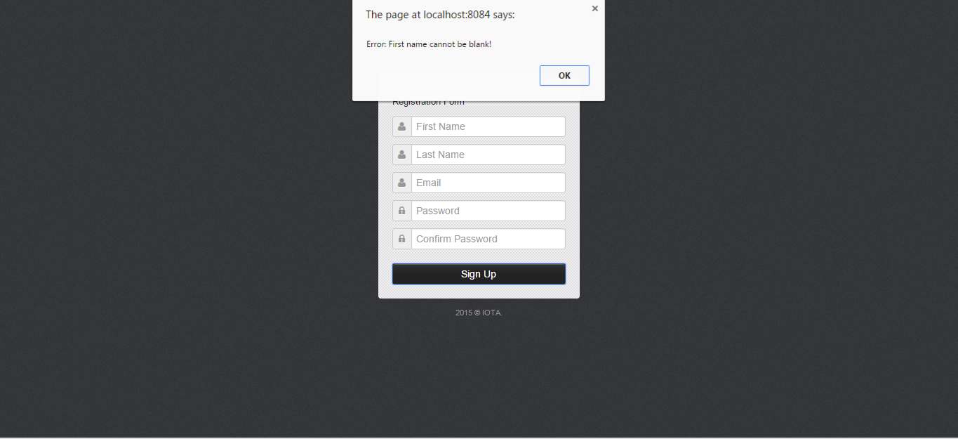

Figure ‎5.4. Blank First Name Error

#### Test Case #2: Blank Last Name

Last Name field mustn’t be blank

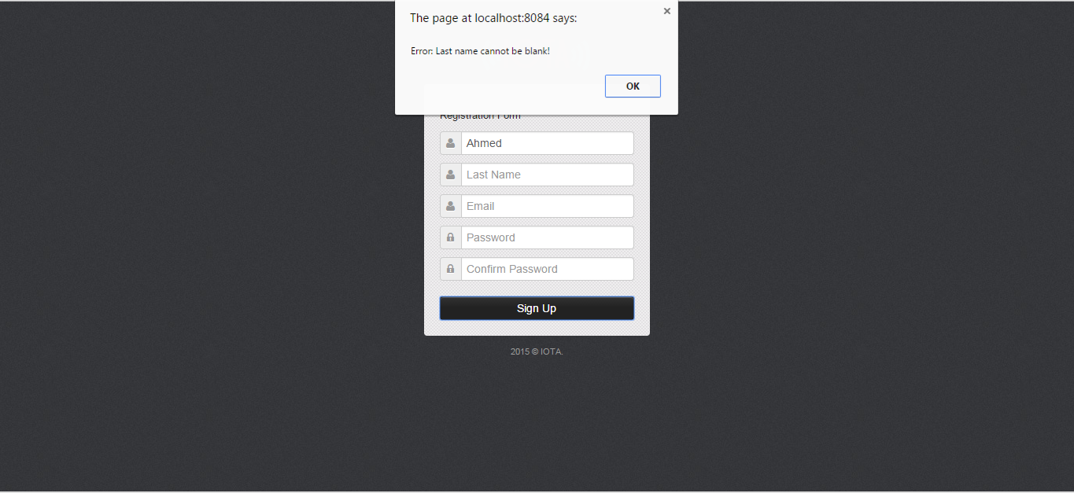

Figure ‎5.5. Blank Last Name Error

#### Test Case #3: Blank Email Address

Email field mustn’t be blank

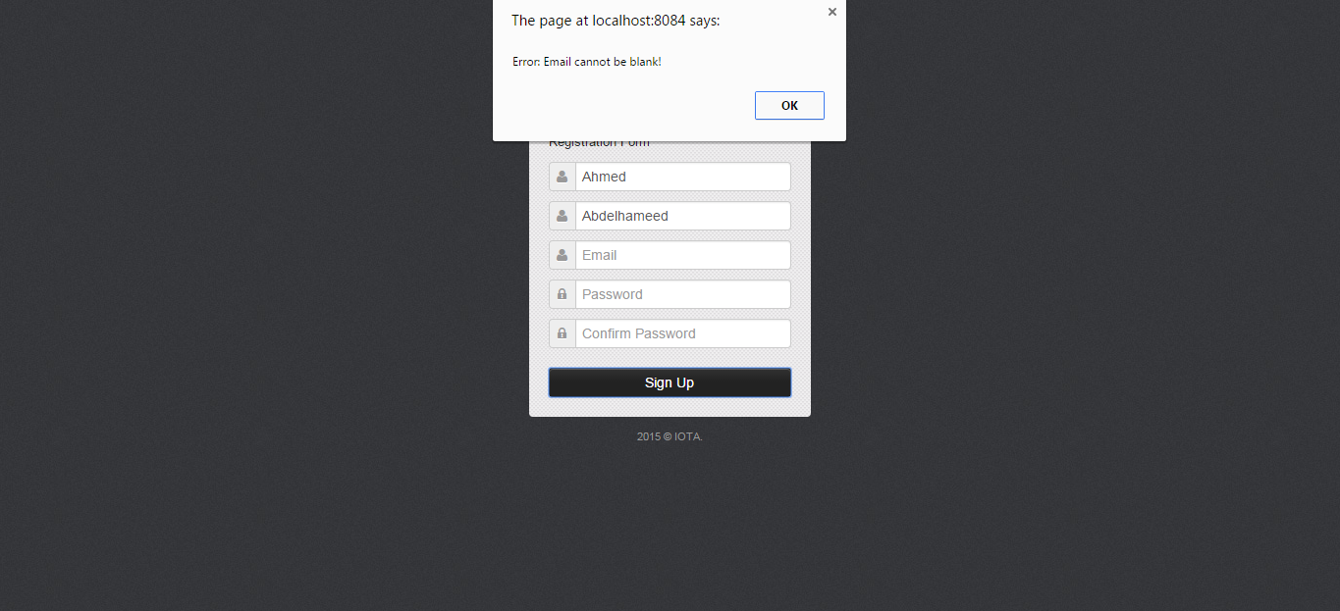

Figure ‎5.6. Blank Email Address Error

#### Test Case #4: Invalid Email Address

The Email field must have a proper email address form of “something@something.something”, otherwise it will be deemed invalid and you will get an error as shown in figure 5.7.

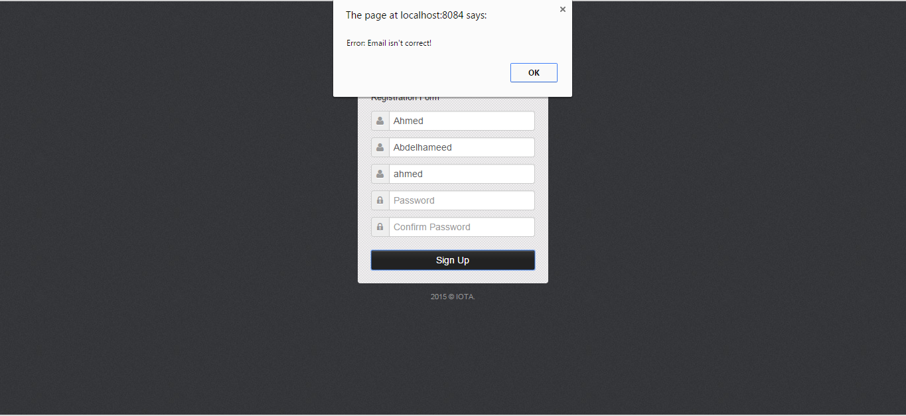

Figure ‎5.7. Invalid Email Address Error

#### Test Case #5: Blank Password/Confirm Password

Password, Confirm password fields mustn’t be blank and must be identical.

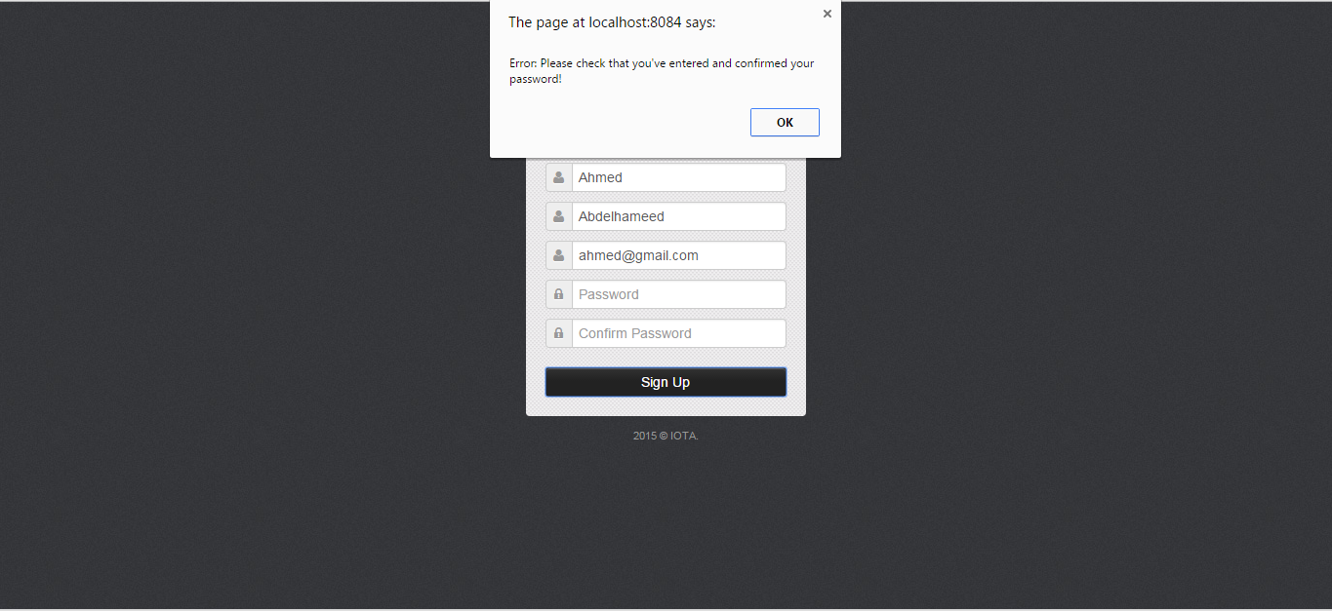

Figure ‎5.8. Blank Password/Confirm Password Error

#### Test Case #6: Different Password and Confirm Password

Password, Confirm password fields mustn’t be blank and must be identical.

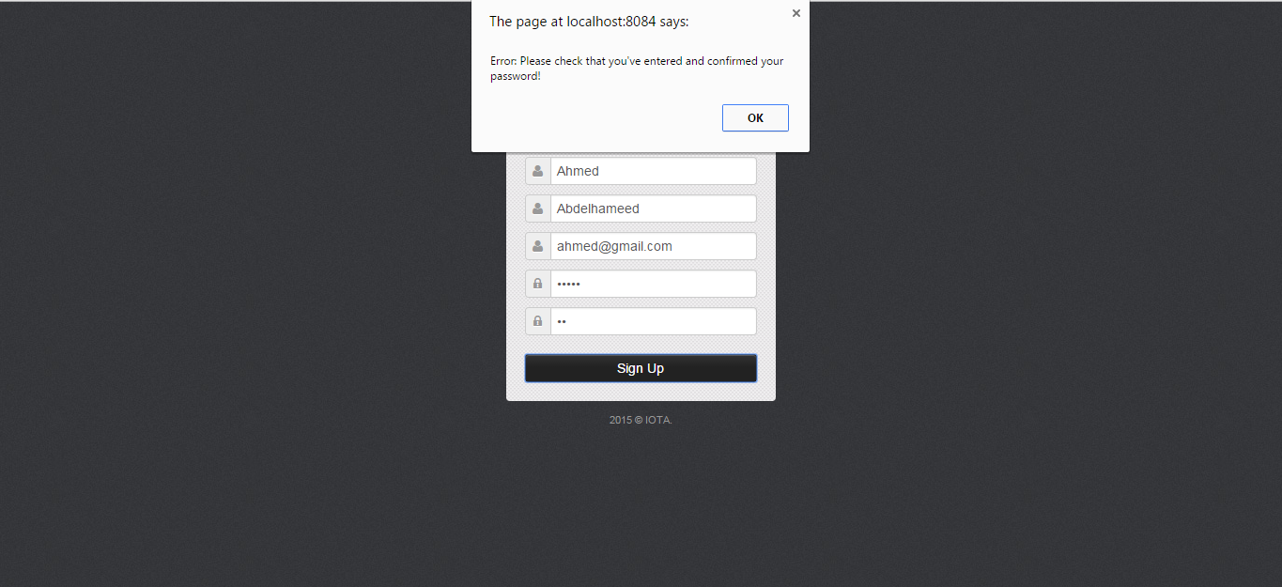

Figure ‎5.9. Password and Confirm Password Don't Match Error

#### Test Case #7: Password Format – Lowercase Letter

Password must contain at least one lower case letter (a-z)

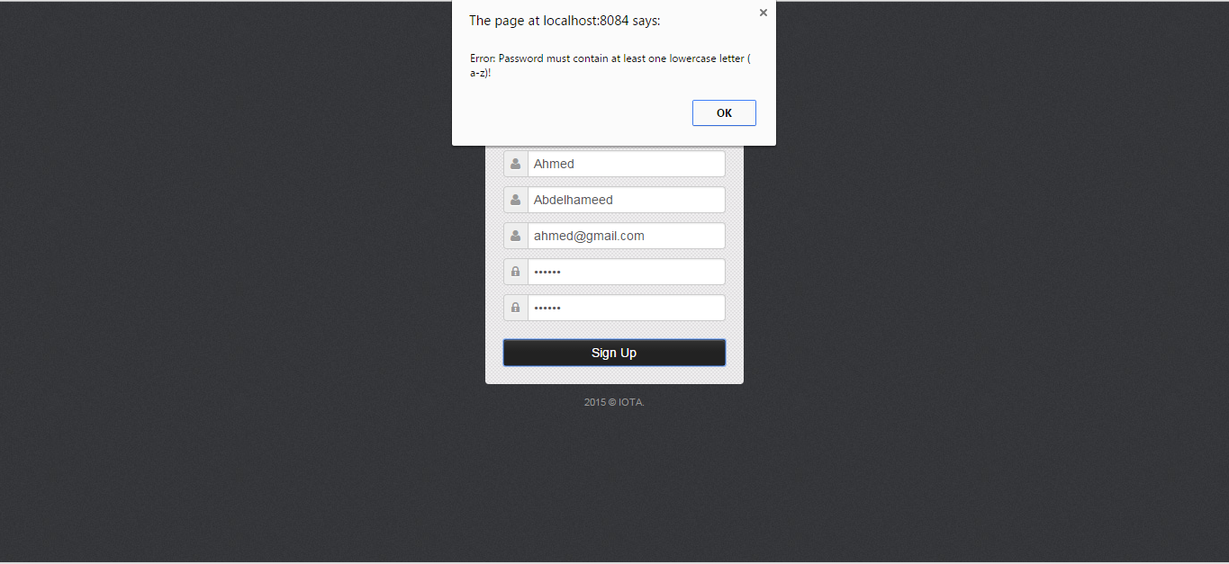

Figure ‎5.10. Password Missing Lowercase Letter Error

#### Test Case #8: Password Format – Uppercase Letter

Password must contain at least one upper case letter (A-Z)

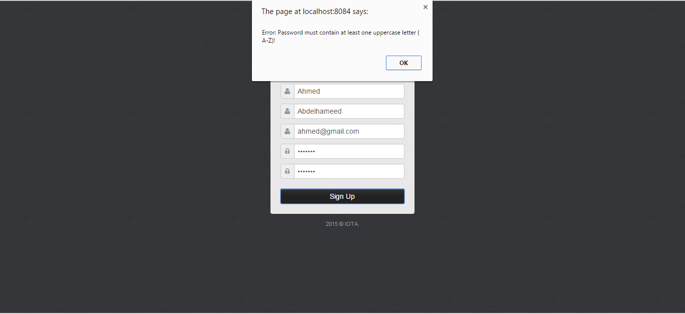

Figure ‎5.11. Password Missing Uppercase Letter Error

#### Test Case #9: Successful Sign Up

When all the above restrictions satisfied the user will successfully sign up and his/her information saved in our data base.

First let’s put correct information that satisfy our restrictions as below:

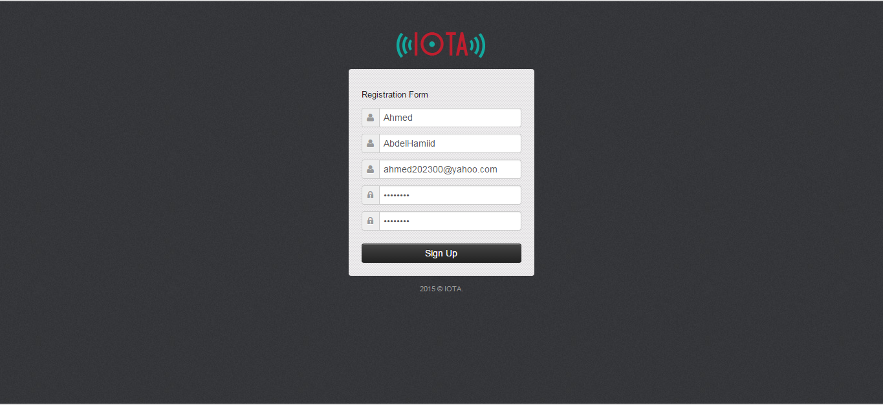

Figure ‎5.12. Filled Registration Form

When the user click on sign up our data base will have this information and the user will be redirected to the login page.

And here is the record added to the data base:

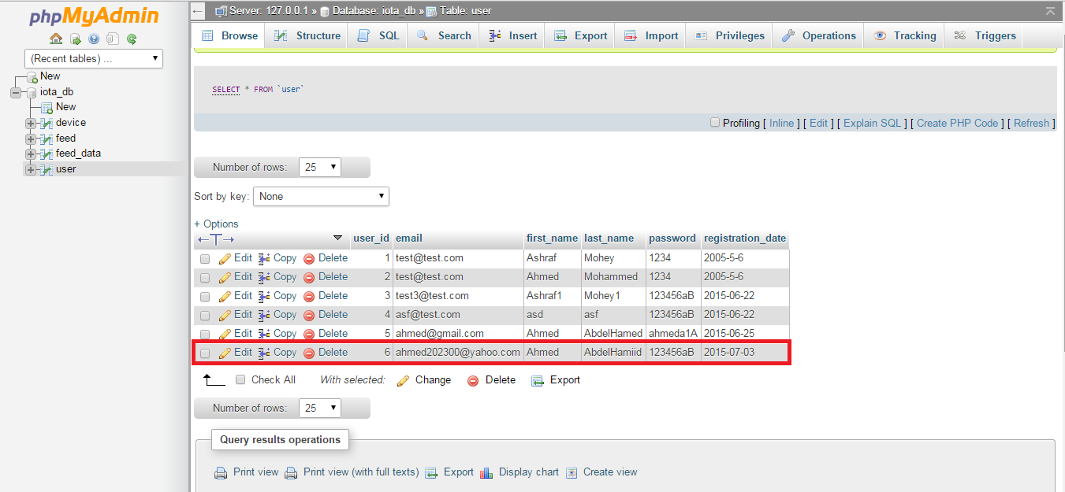

Figure ‎5.13. User Database Entry

### Login Test Cases

#### Test Case #1: Invalid Login

If the users don’t enter a user name doesn’t exists or a user name with a wrong password the login will not proceed and it will redirect the user to the login page again.

#### Test Case #2: Successful Login

If the user enters right user name and right password and clicked on login button it will redirect him/her to his dash board like the below figures:

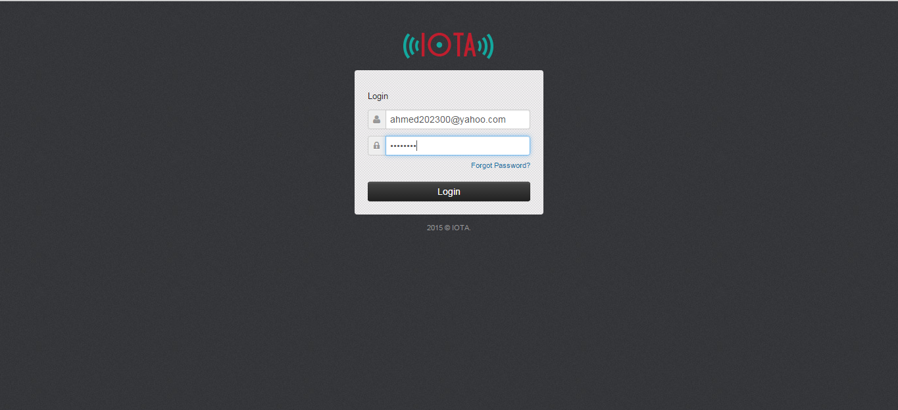

Figure ‎5.14. Filled Login Form

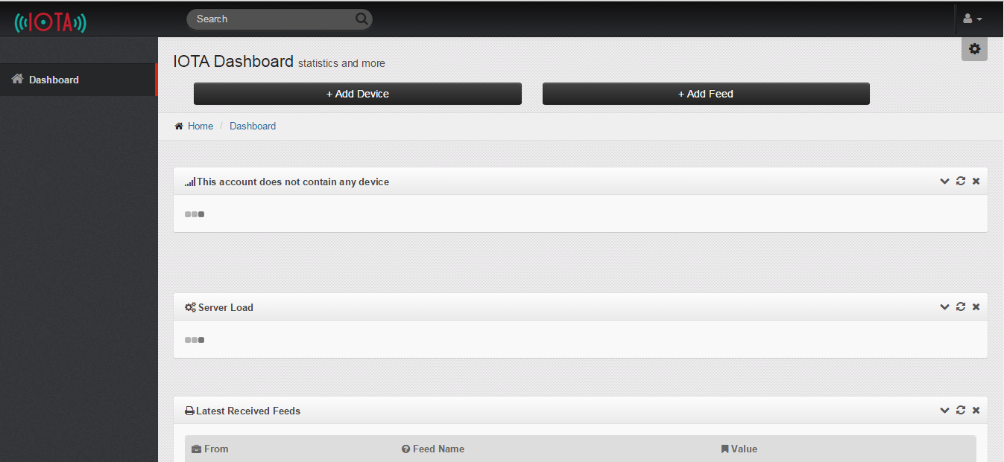

Figure ‎5.15. IOTA Dashboard

The dash board above is blank because the user is new and still hasn’t added any devices.

### Dashboard Functionalities Test Cases

#### Test Case #1: Add Device Button

The user will start by adding a device so he/she will click on add device button and it will open the following page “Add Device” page.

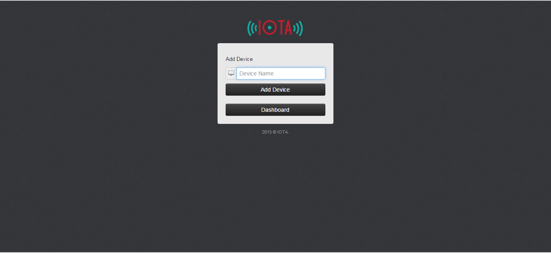

Figure ‎5.16. Add Device Page

#### Test Case #2: Blank Device Name

The device name mustn’t be blank.

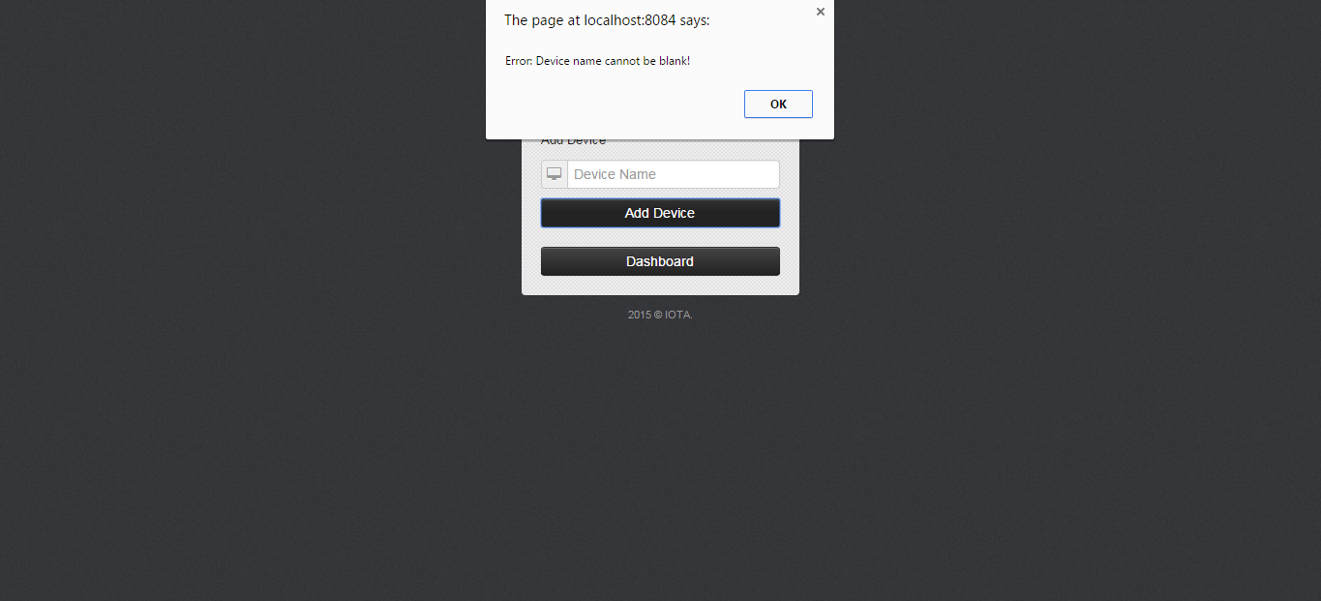

Figure ‎5.17. Blank Device Name Error

#### Test Case #3: Successful Add Device

The user can add the device by clicking on add device button then he will redirected into the dash board by his device added or he can change his mind and click on the dash board button to return to the dash board without adding the device.

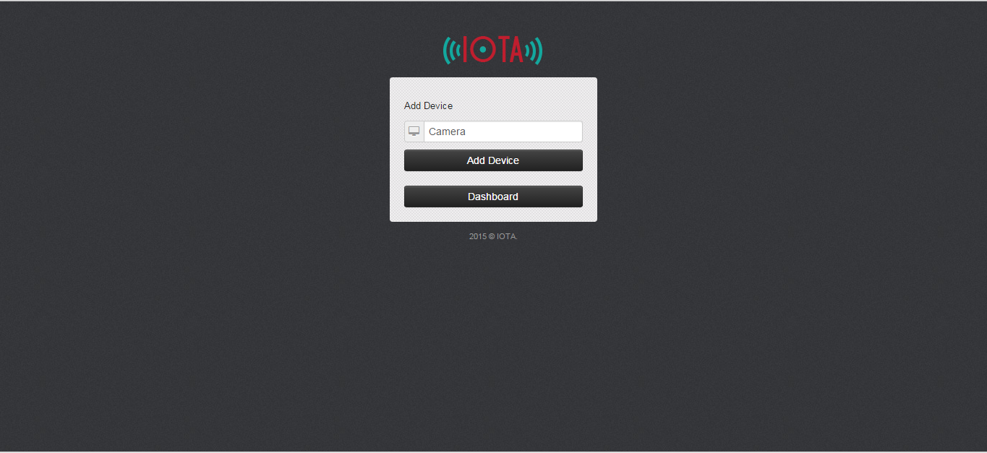

Figure ‎5.18. Filled Device Name

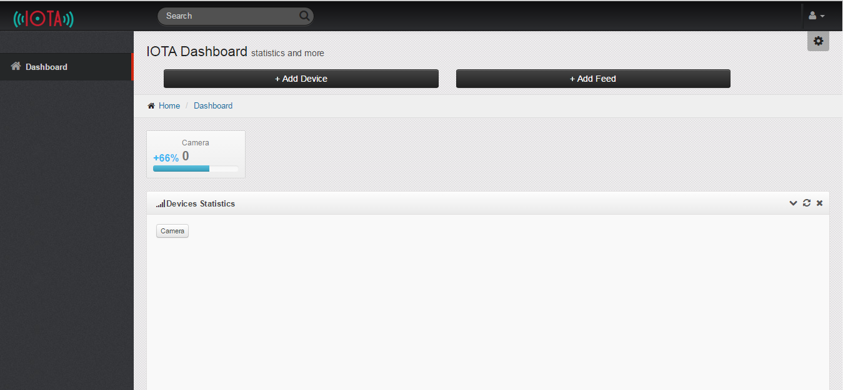

Figure ‎5.19. Device Button on Dashboard

And here is the record added into our database.

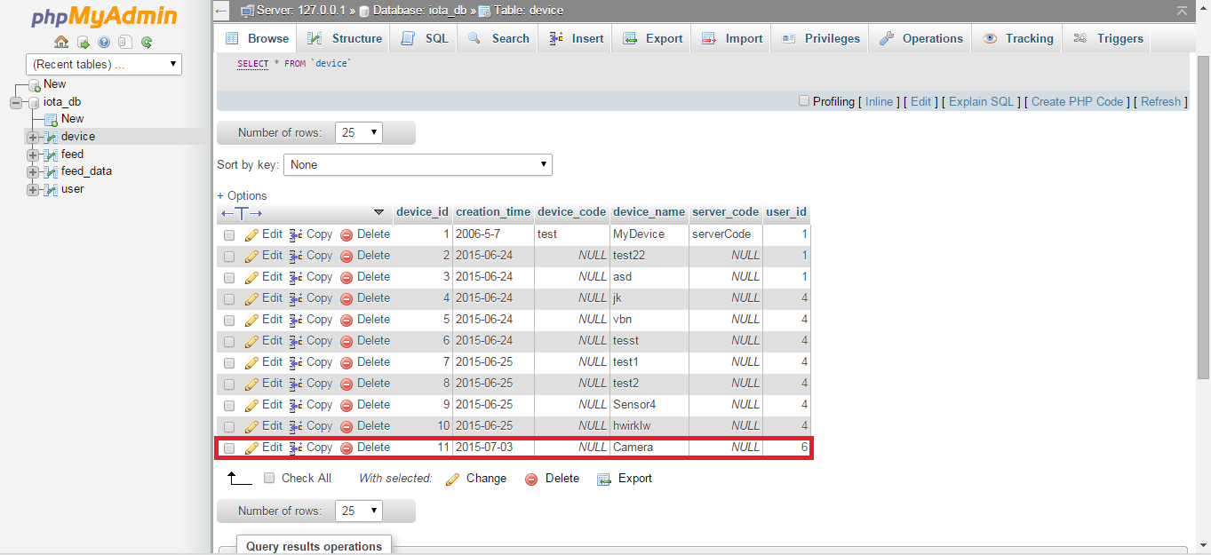

Figure ‎5.20. Device Database Entry

#### Test Case #4: Add Feed Button

The user can add feed to his device by click on add feed button and it will redirect him/her to add feed page.

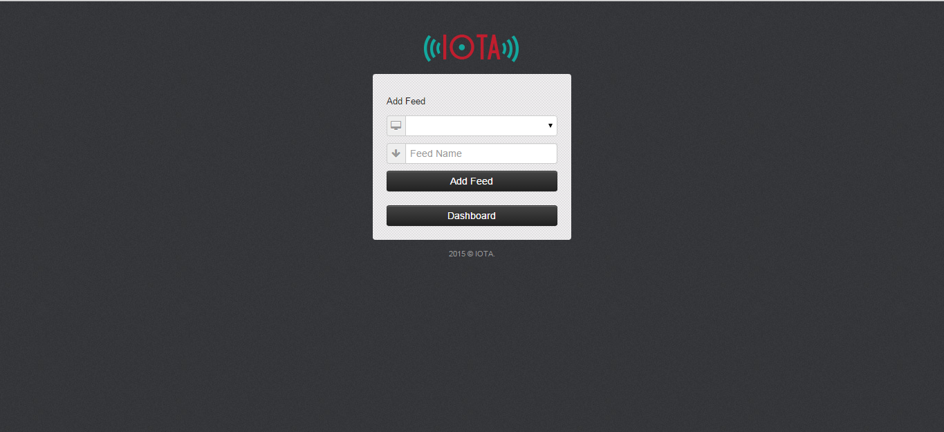

Figure ‎5.21. Add Feed Page

#### Test Case #5: Add Feed Dropdown List

The user can select the device he want to add feed to it from the drop down list.

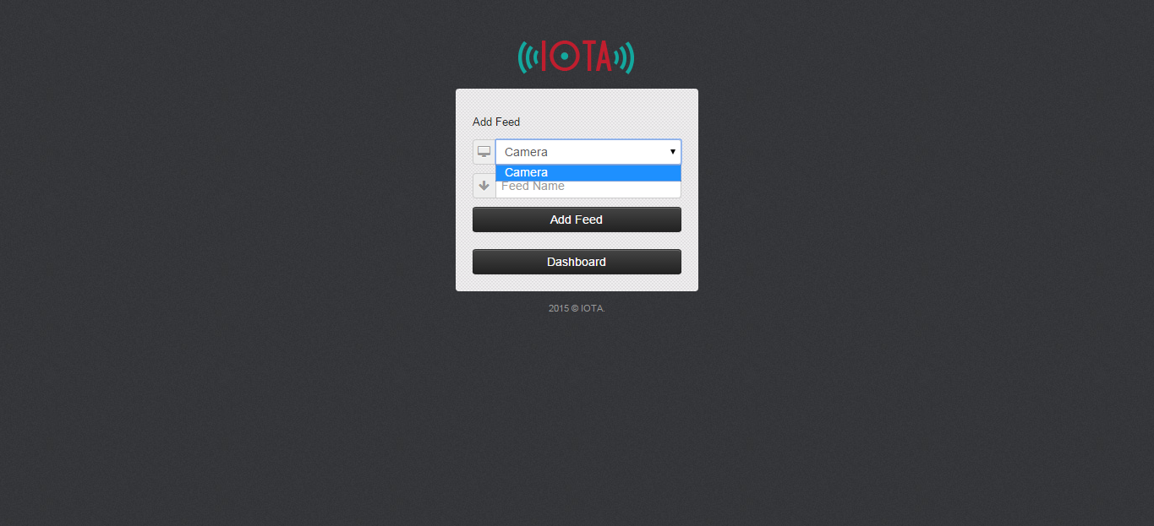

Figure ‎5.22. Add Feed Devices' Dropdown List

#### Test Case #6: Blank Feed Name

The feed name field mustn’t be blank.

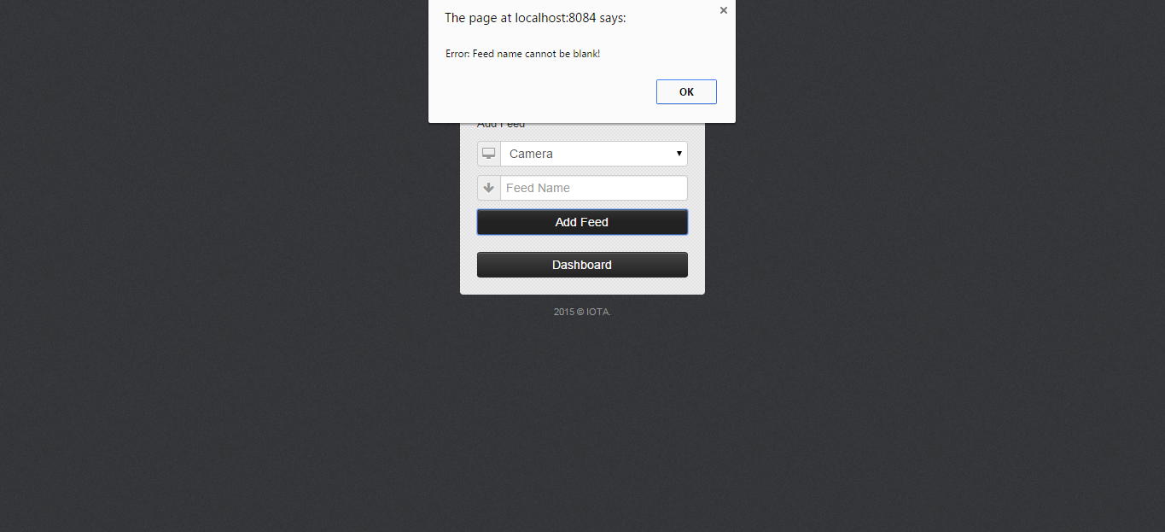

Figure ‎5.23. Blank Feed Name Error

#### Test Case #7: Add Feed

The user can add the feed by clicking on add feed button then he will redirected into the dash board by his feed added or he can change his mind and click on the dash board button to return to the dash board without adding the feed.

Show the figures below:

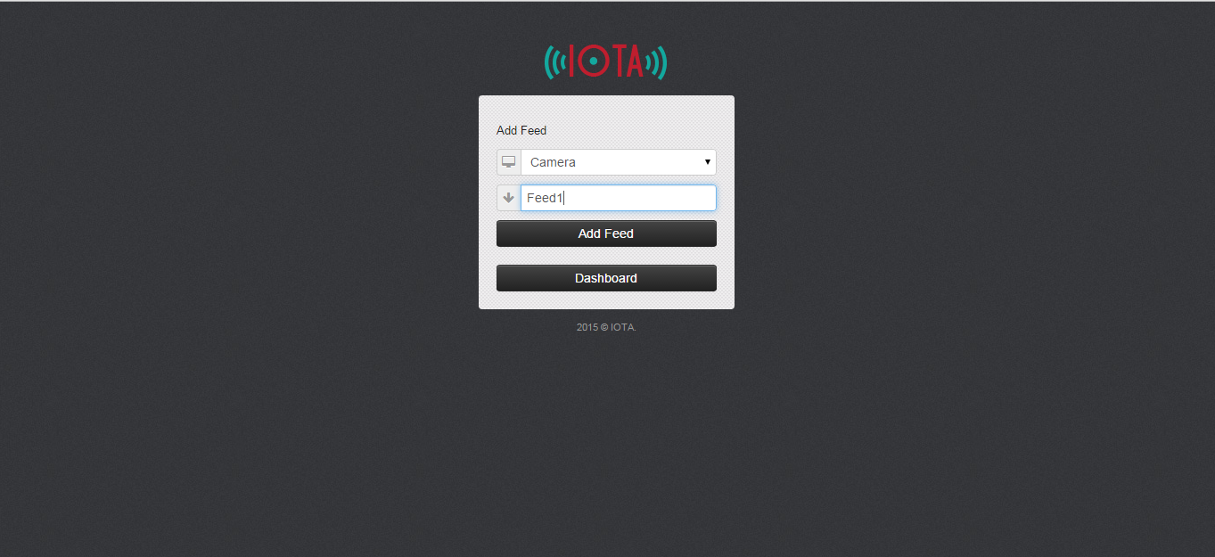

Figure ‎5.24. Filled Add Feed Form

And here is the record added into our database.

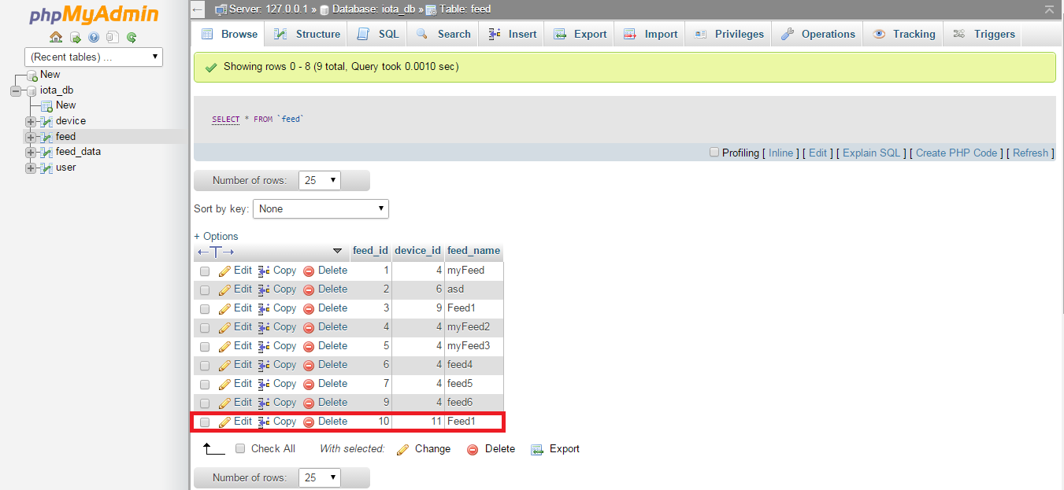

Figure ‎5.25. Feed Database Entry

#### Test Case #8: Devices’ Buttons

If we add more devices a new buttons for this devices will appear besides the camera button and also the graph will have button for each device in order to navigate between every device graph.

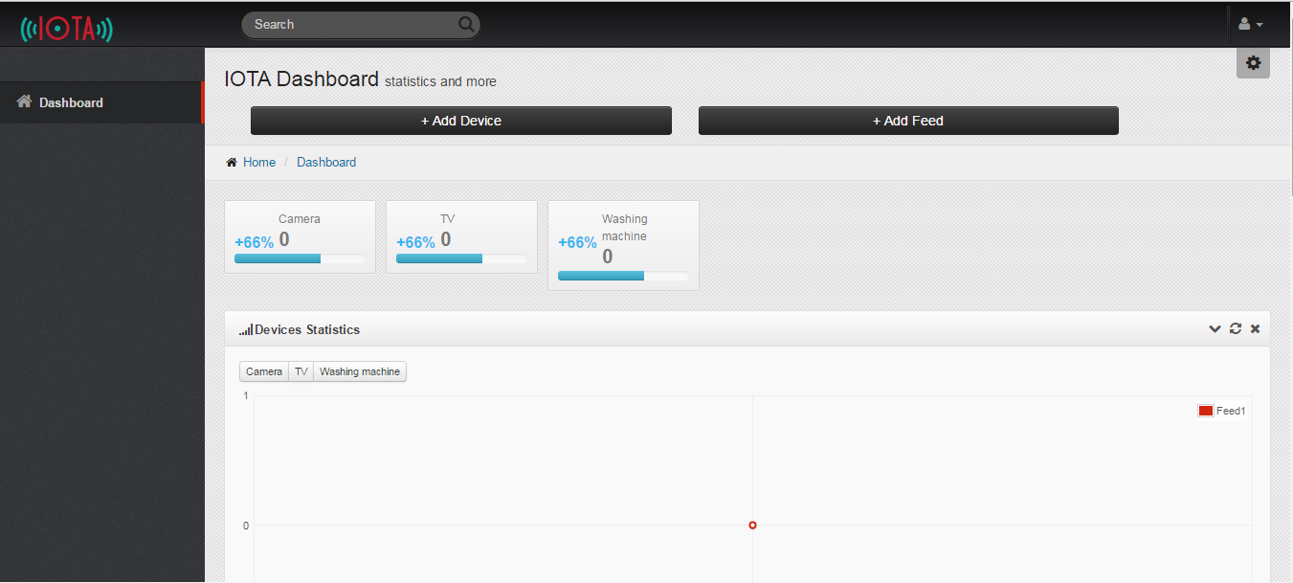

Figure ‎5.26. Devices' Buttons on Dashboard

#### Test Case #9: Device Button - Redirect

If we clicked into a device button it will redirect the user into the device page of this device.

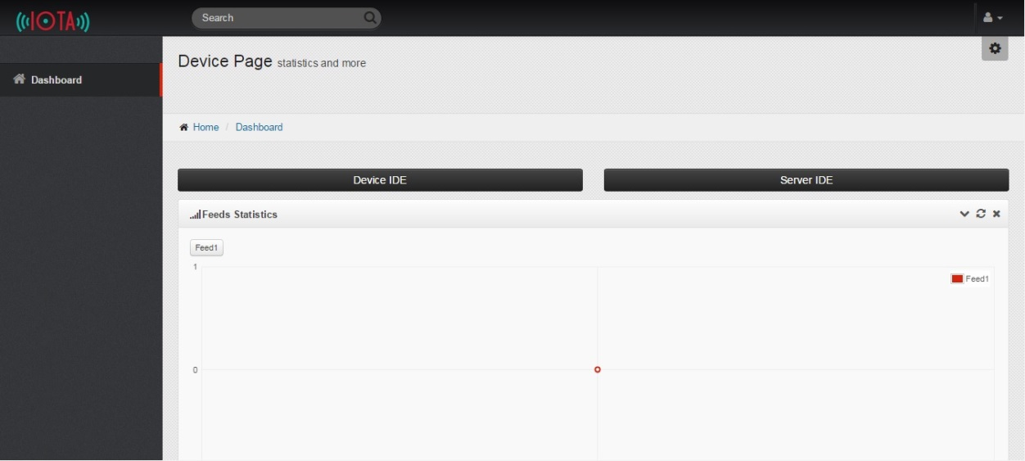

Figure ‎5.27. Device Page

#### Test Case #10: Sign Out

The user can sign out any time by clicking on the icon on the top-right of any page and click on Log out and he/she will be redirected into the login page.

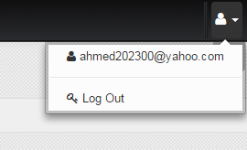

Figure ‎5.28. Sign Out

### Device Page Functionalities Test Cases

The device page contains a graph of the device with its feeds and a table of the latest received values for the feeds.

#### Test Case #1: Device IDE Button

When the user want to open the device IDE he/she will click on the device IDE button and the device IDE page will be opened.

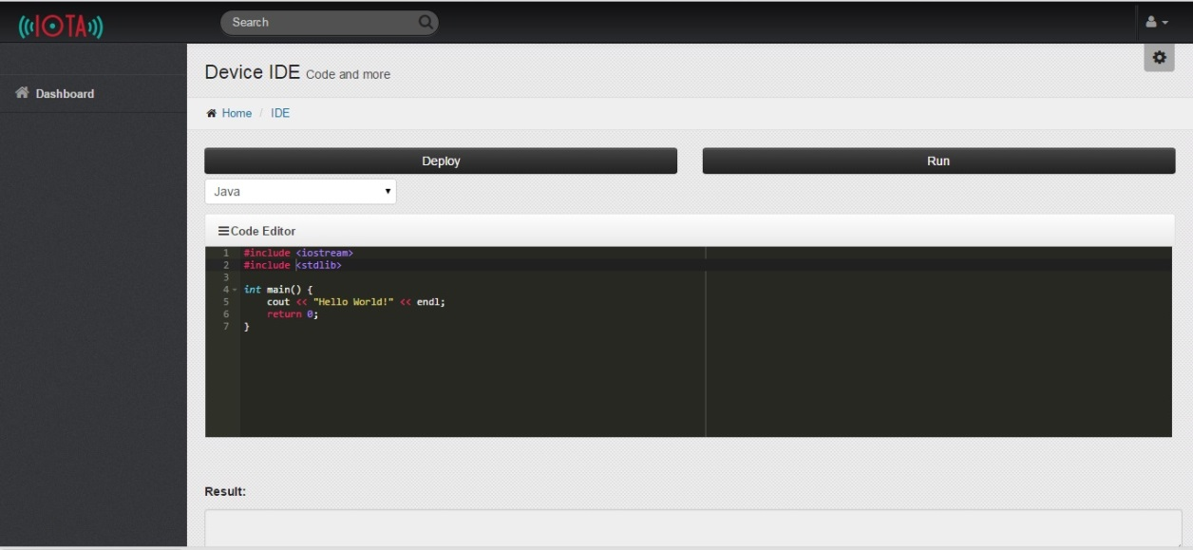

Figure ‎5.29. Device IDE

#### Test Case #2: Server IDE Button

When the user want to open the device IDE he/she will click on the server IDE button and the server IDE page will be opened.

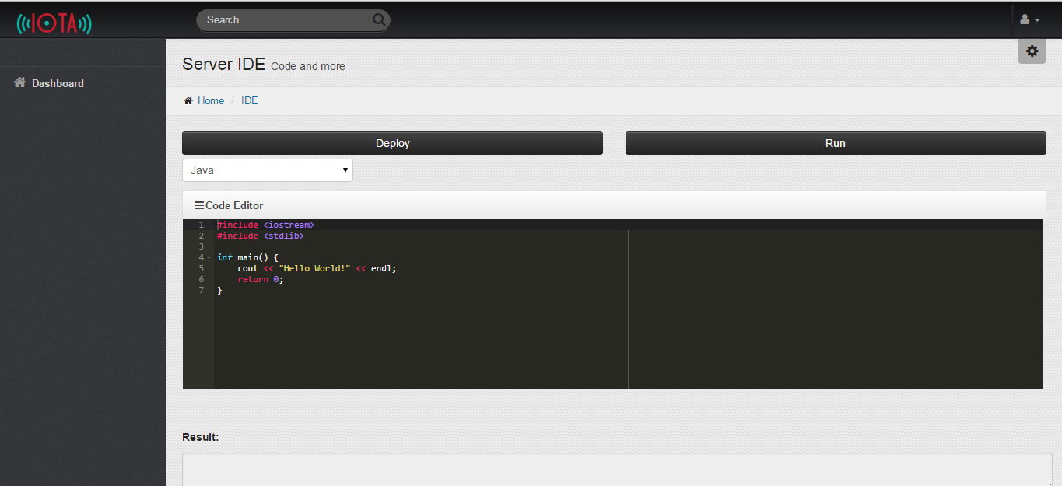

Figure ‎5.30. Server IDE

The user also can return to the dashboard at any time by click on the dashboard button at the left, this button is in the device page, server IDE and device IDE.

### IDE Test Cases

#### Test Case #1: C++ Successful Run

When the user selects C++, enters correct C++ code in the IDE and runs it, it will show the result below in the Result textbox.

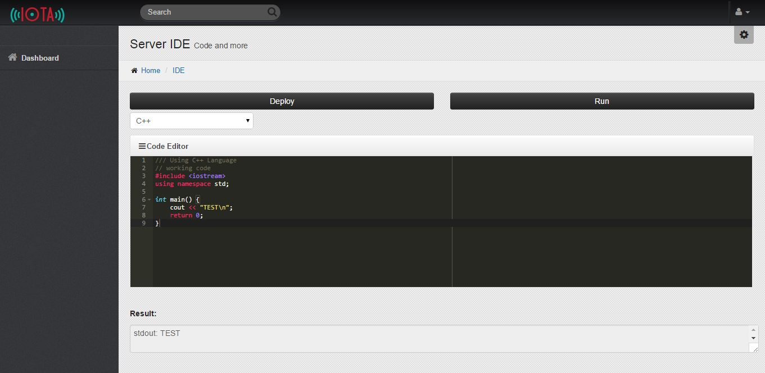

Figure ‎5.31. C++ Successful Run

#### Test Case #2: Namespace Undeclared

If the user forgets to declare the used namespace, they will receive an error.

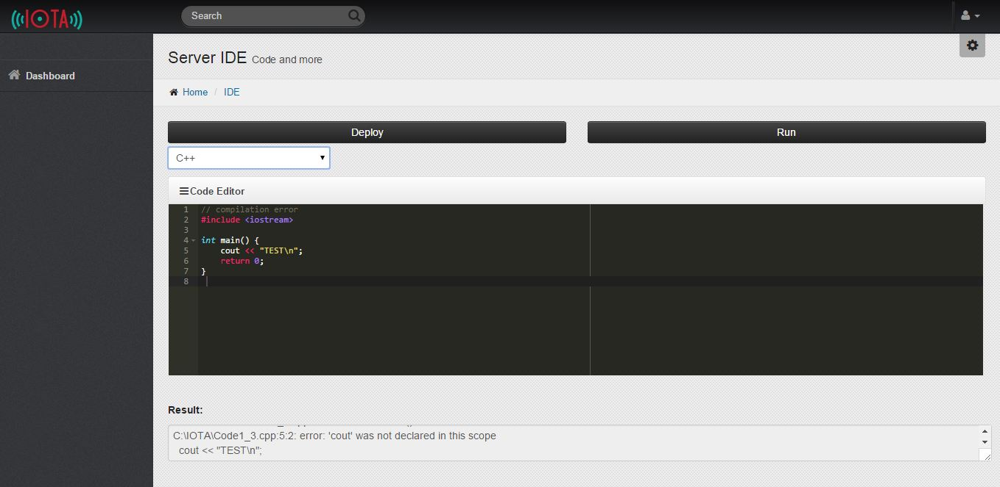

Figure ‎5.32. Namespace Undeclared

#### Test Case #3: Java Successful Run

When the user selects Java, enters correct Java code in the IDE and runs it, it will show the result below in the Result textbox.

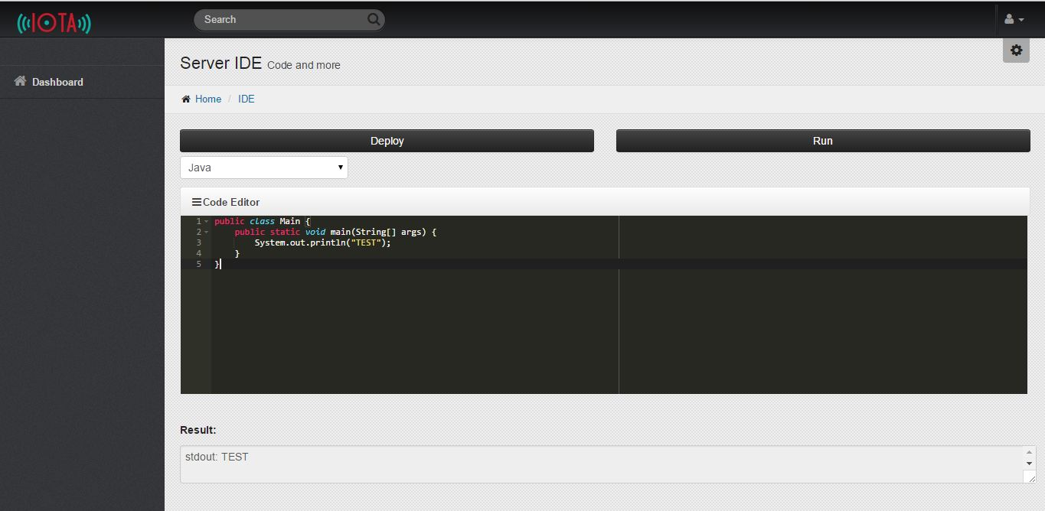

Figure ‎5.33. Java Successful Run

#### Test Case #4: GET_DATA

The user can use the function “GET_DATA” which we introduced to the user to allow them to access the values saved and use it into their code.

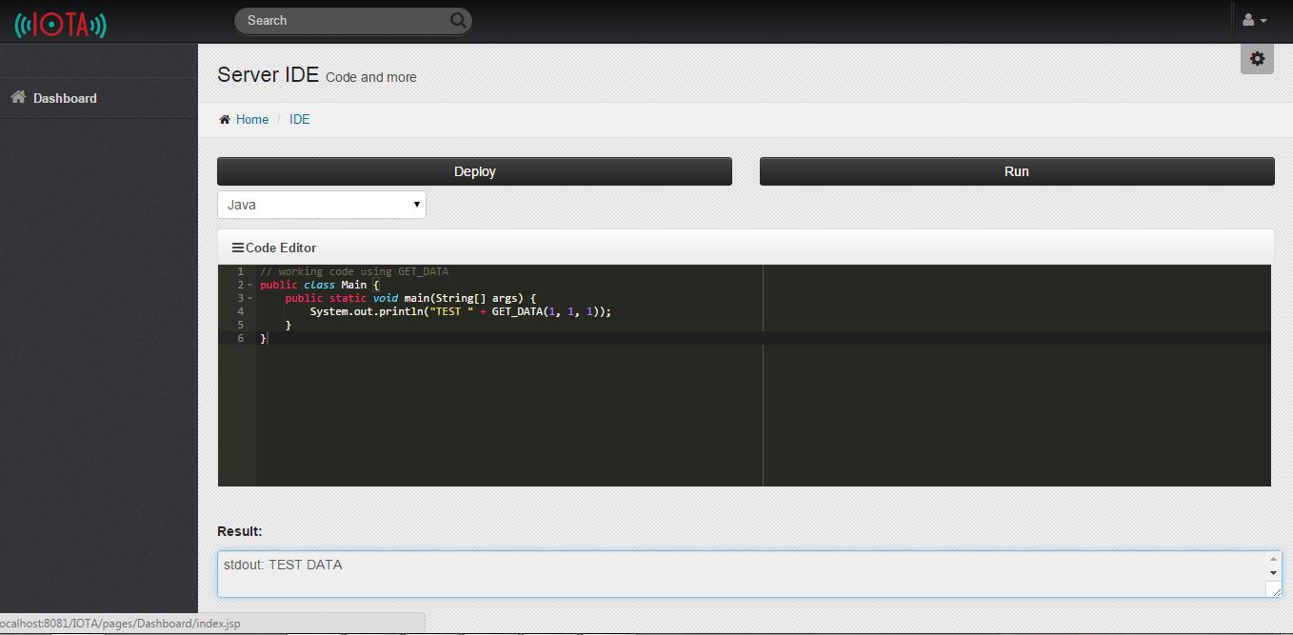

Figure ‎5.34. GET_DATA Function

#### Test Case #5: Main Class Error

The class used in java must be called Main for the code to successfully compile and if the user enters a wrong class name, an error will be shown telling the user about the issue and how to correct the code.

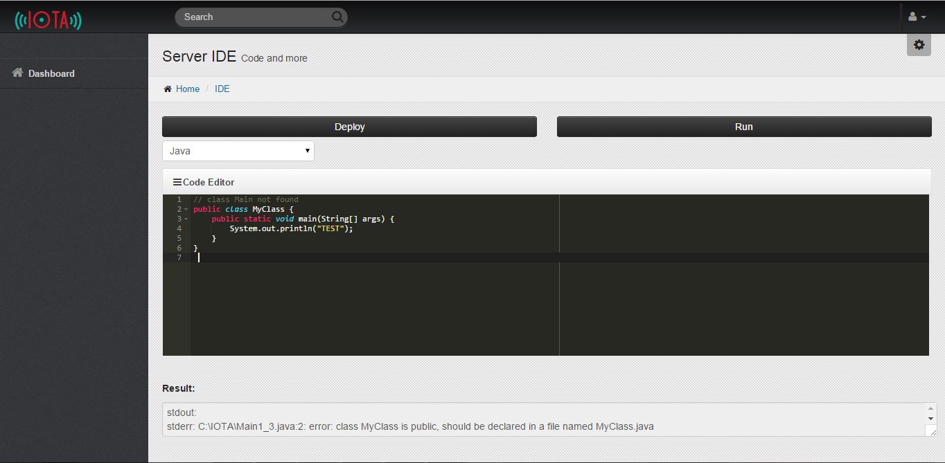

Figure ‎5.35. Main Class Error

#### Test Case #6: Incorrect Java Code

If the user enters a wrong code like missing a semicolon for example, an error will be displayed explaining the problem with an indication to the location of the error.

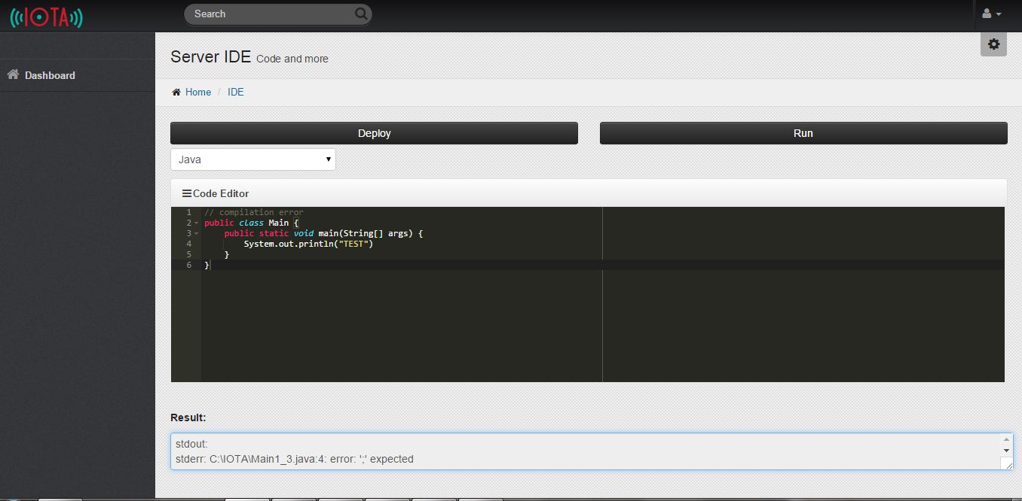

Figure ‎5.36. Incorrect Java Code

## Conclusions

### Future Work

The following are concepts that we have researched about that we plan to implement in the future to our project for multiple reasons including speed, simplicity and efficiency.

#### NoSQL

A NoSQL (often interpreted as Not only SQL) database provides a mechanism for storage and retrieval of data that is modeled in means other than the tabular relations used in relational databases.

Motivations for this approach include simplicity of design, presumed better horizontal scaling, and presumed finer control over availability. The data structures used by NoSQL databases (e.g. key-value, graph, or document) differ slightly from those used by default in relational databases, making some operations faster in NoSQL and others faster in relational databases. The particular suitability of a given NoSQL database depends on the problem it must solve.

NoSQL databases are increasingly used in big data and real-time web applications. NoSQL systems are also called "Not only SQL" to emphasize that they may also support SQL-like query languages.

Many NoSQL stores compromise consistency (in the sense of the CAP theorem) in favor of availability and partition tolerance. Barriers to the greater adoption of NoSQL stores include the use of low-level query languages, the lack of standardized interfaces, and huge investments in existing SQL.

#### 6LoWPAN

6LoWPAN is an acronym of IPv6 over Low power Wireless Personal Area Networks. 6LoWPAN is the name of a concluded working group in the Internet area of the IETF.

The 6LoWPAN concept originated from the idea that "the Internet Protocol could and should be applied even to the smallest devices," and that low-power devices with limited processing capabilities should be able to participate in the Internet of Things.

The 6LoWPAN group has defined encapsulation and header compression mechanisms that allow IPv6 packets to be sent and received over IEEE 802.15.4 based networks. IPv4 and IPv6 are the work horses for data delivery for local-area networks, metropolitan area networks, and wide-area networks such as the Internet. Likewise, IEEE 802.15.4 devices provide sensing communication-ability in the wireless domain. The inherent natures of the two networks though, are different.

The target for IP networking for low-power radio communication are applications that need wireless internet connectivity at lower data rates for devices with very limited form factor. Examples could include, but are not limited to: automation and entertainment applications in home, office and factory environments. The header compression mechanisms standardized in RFC6282 can be used to provide header compression of IPv6 packets over such networks.

IPv6 is also in use on the smart grid enabling smart meters and other devices to build a micro mesh network before sending the data back to the billing system using the IPv6 backbone. Some of these networks run over IEEE 802.15.4 radios, and therefore use the header compression and fragmentation as specified by RFC6282.

# **Appendix I**

**Glossary**

*“A good dictionary can only help.”*

*- Mary Norris*

*Irish Author*

# Glossary

**AES** (Advanced Encryption Standard) is a specification for the encryption of electronic data established by the U.S. National Institute of Standards and Technology (NIST) in 2001.

**Client** is a piece of computer hardware or software that accesses a service made available by a server. The server is often (but not always) on another computer system, in which case the client accesses the service by way of a network. The term applies to programs or devices that are part of a client–server model.

**Cloud Computing** refers to the practice of transitioning computer services such as computation or data storage to multiple redundant offsite locations available on the Internet, which allows application software to be operated using internet-enabled devices.

**Dashboard** is an easy to read, often single page, real-time user interface, showing a graphical presentation of the current status (snapshot) and historical trends of an organization’s or computer appliances key performance indicators to enable instantaneous and informed decisions to be made at a glance.

**Data** is a set of values of qualitative or quantitative variables; restated, pieces of data are individual pieces of information. Data is measured, collected and reported, and analyzed, whereupon it can be visualized using graphs or images.

**Database** is a collection of information that is organized so that it can easily be accessed, managed, and updated. In one view, databases can be classified according to types of content: bibliographic, full-text, numeric, and images.

**DBMS** (Database Management System) is system software for creating and managing databases. The DBMS provides users and programmers with a systematic way to create, retrieve, update and manage data.

**Embedded Device** is an object that contains a special-purpose computing system. The system, which is completely enclosed by the object, may or may not be able to connect to the Internet. Embedded systems have extensive applications in consumer, commercial, automotive, industrial and healthcare markets.

**Firmware** is a tangible electronic component with embedded software instructions, such as a BIOS. Typically they are used to tell an electronic device how to operate.

**Hardware** is the physical parts or components of a computer, such as the monitor, mouse, keyboard, computer data storage, hard disk drive (HDD), system unit (graphic cards, sound cards, memory, motherboard and chips), and so on, all of which are physical objects that can be touched (that is, they are tangible).

**HTTP** (Hypertext Transfer Protocol) is an application protocol for distributed, collaborative, hypermedia information systems. HTTP is the foundation of data communication for the World Wide Web. Hypertext is structured text that uses logical links (hyperlinks) between nodes containing text.

**Hz** (Hertz) is the unit of frequency in the International System of Units and is defined as one cycle per second. It is named for Heinrich Rudolf Hertz, the first person to provide conclusive proof of the existence of electromagnetic waves.

**IDE** (Integrated Development Environment) is a software application that provides comprehensive facilities to computer programmers for software development. An IDE normally consists of a source code editor, build automation tools and a debugger.

**IOT** (Internet of Things) is the network of physical objects or "things" embedded with electronics, software, sensors, and connectivity to enable it to achieve greater value and service by exchanging data with the manufacturer, operator and/or other connected devices.

**IP Address** (Internet Protocol Address) is a numerical label assigned to each device (e.g., computer, printer) participating in a computer network that uses the Internet Protocol for communication. An IP address serves two principal functions: host or network interface identification and location addressing.

**Java** is a general-purpose computer programming language that is concurrent, class-based, object-oriented, and specifically designed to have as few implementation dependencies as possible.

**Linux** is a Unix-like computer operating system (OS) assembled under the model of free and open-source software development and distribution.

**Linux Kernel** is a Unix-like computer operating system kernel. The Linux kernel is a widely used operating system kernel world-wide; the Linux operating system is based on it and deployed on both traditional computer systems, usually in the form of Linux distributions, and on embedded devices such as routers. The Android operating system for tablet computers and smartphones is also based atop the Linux kernel.

**Module** is any of a number of distinct but interrelated units from which a program may be built up or into which a complex activity may be analyzed.

**MQTT** (MQ Telemetry Transport) is a machine-to-machine (M2M)/"Internet of Things" connectivity protocol. It was designed as an extremely lightweight publish/subscribe messaging transport. It is useful for connections with remote locations where a small code footprint is required and/or network bandwidth is at a premium.

**MySQL** is the world's second most widely used relational database management system (RDBMS) and most widely used open-source RDBMS.

**OTA** (Over-the-air programming) refers to various methods of distributing new software updates, configuration settings, and even updating encryption keys to devices where one central location can send an update to all the users, who are unable to refuse, defeat, or alter that update, and the update applies immediately to everyone on the channel.

**Protocol** (Communication Protocol) is a system of rules that allow two or more entities of a communication system to communicate between them to transmit information via any kind of variation of a physical quantity.

**RDBMS** (Relational Database Management System) is a database management system (DBMS) that is based on the relational model as invented by E. F. Codd, of IBM's San Jose Research Laboratory. Many popular databases currently in use are based on the relational database model.

**REST** (Representational State Transfer) is a software architecture style consisting of guidelines and best practices for creating scalable web services. It’s a coordinated set of constraints applied to the design of components in a distributed hypermedia system that can lead to a more performant and maintainable architecture.

**RSA** (Rivest-Shamir-Adleman Cryptosystem) is one of the first practical public-key cryptosystems and is widely used for secure data transmission. In such a cryptosystem, the encryption key is public and differs from the decryption key which is kept secret.

**Server** is both a running instance of some software capable of accepting requests from clients, and the computer such a server runs on. Servers operate within a client-server architecture where "servers" are computer programs running to serve the requests of other programs, the "clients".

**Software** is any set of machine-readable instructions that directs a computer's processor to perform specific operations.

**SQL** is a standard language for accessing databases. Our SQL tutorial will teach you how to use SQL to access and manipulate data in: MySQL, SQL Server, Access, Oracle, Sybase, DB2, and other database systems.

**SSL** (Secure Sockets Layer) provides a secure connection between internet browsers and websites, allowing you to transmit private data online. Sites secured with SSL display a padlock in the browsers URL and possibly a green address bar if secured by an EV Certificate.

**TCP** (Transmission Control Protocol) is one of the main protocols in TCP/IP networks. Whereas the IP protocol deals only with packets, TCP enables two hosts to establish a connection and exchange streams of data. TCP guarantees delivery of data and also guarantees that packets will be delivered in the same order in which they were sent.

**TLS** (Transport Layer Security) is a cryptographic protocol designed to provide communications security over a computer network. It uses X.509 certificates and hence asymmetric cryptography to authenticate the counterparty with whom they are communicating, and to negotiate a symmetric session key.

**UI** (User Interface) is the space where interactions between humans and machines occur. The goal of this interaction is to allow effective operation and control of the machine from the human end, whilst the machine simultaneously feeds back information that aids the operators' decision making process.

**URL** (Uniform Resource Locator) is a reference to a resource that specifies the location of the resource on a computer network and a mechanism for retrieving it.

**Web Browser** is a software application for retrieving, presenting and traversing information resources on the World Wide Web.

# References

- Architecting the Internet of Things

Authors: Dieter Uckelmann, Mark Harrison, Florian Michahelles

Publisher: Springer

Publication Date: 2011 edition (April 12, 2011)

Hardcover: 353 pages

- Designing the Internet of Things

Authors: Adrian McEwen, Hakim Cassimally

Publisher: Wiley

Publication Date: 1 edition (December 9, 2013)

Paperback: 336 pages

- The Silent Intelligence: The Internet of Things

Authors: Daniel Kellmereit, Daniel Obodovski

Publisher: DND Ventures LLC

Publication Date: 1 edition (September 20, 2013)

Paperback: 166 pages

- Internet of Things (A Hands-on-Approach)

Authors: Vijay Madisetti, Arshdeep Bahga

Publisher: VPT

Publication Date: 1 edition (August 9, 2014)

Paperback: 446 pages

- Wikipedia

www.Wikipedia.org

Last Visit Date: July 5th, 2015